Foundations of Data Management

INF- 551 Spring 2020

**Keyword-Driven Exploration of Relational Data Using Firebase**

**Midterm Project Report**

Sairam Kamal Raj Tejaswini Prakash Kulkarni

Contents

Current status and timelines of the Project: 3

Datasets used: 3

Steps carried out in order to achieve the above-mentioned status: 3

Screenshots of the Completed components: 4

UI: 4

Challenges encountered: 5

Summary Report:  5

# 

# Current status of the Project:

# 

# About the datasets used:

As decided in the project proposal stage, we have been working on the following 2 datasets:

1. SF Bay Area Bike Share
2. Questions from Cross Validated Stack Exchange

Apart from the above mentioned data sets we also decided to analyze and use Novel Corona dataset which is an ongoing pandemic.

We have also loaded the “World” data set provided by the instructional faculty.

# Steps carried out in order to achieve the above-mentioned status:

1. Loaded the data from kaggle onto a dataframe and cleaned the data.
2. Data cleansing process involved the following steps:
   * 1. Ensuring that the correct file format was used to read the files in order to overcome errors like file not been able to decode utf-8 and avoiding special characters which hinders loading data onto Firebase.
     2. Formatting all the column names and renaming them incase if they are dirty: lowercase and removing of special characters (except underscore and white space).
     3. Obtaining column datatypes for all the features and ensuring that the data follows the domain constraints.
     4. Converting the format of date columns to YYYY-MM-DD, a format that is in compliant with MySQL database.
     5. Removing html specific tags such as <p>, </p> etc… that were present in stack overflow data.
     6. Dropped duplicate rows in the data.
     7. Cleansing of null values by replacing with 0’s or “Unavailable” based on the datatype of the column.
     8. Testing of removal of data that hinders loading onto firebase.
3. Setting up of MySQL database in EC2 with root credentials and created the required tables and provided all privileges to user INF551.
4. Automated the process of loading the values in MySQL from the datasets using Python code.
5. Automated the process of extracting data from MySQL database using python using input parameters as database name and the name of the database to be written in firebase.
6. Created JSON data from the data which is present on MySQL using Python scripts.
7. Utilized the created JSON data to load on to the firebase.
8. Created inverted index for each dataset which included the following steps:
   * 1. Reading the text data from each of the datasets individually.
     2. Cleansing the text data by converting to lowercase, removing the special characters and splitting the data based on space.
     3. Indexing each file based on the primary keys.
9. Loading of data onto firebase, included the following tasks:

Ensure that there is no pre-existing data. Deletion of data if it is already present on the firebase and loading data fresh.

Loading of clean data on firebase real-time database.

# Screenshots of the Completed components:

Cleaned Kaggle Datasets:

station_clean:

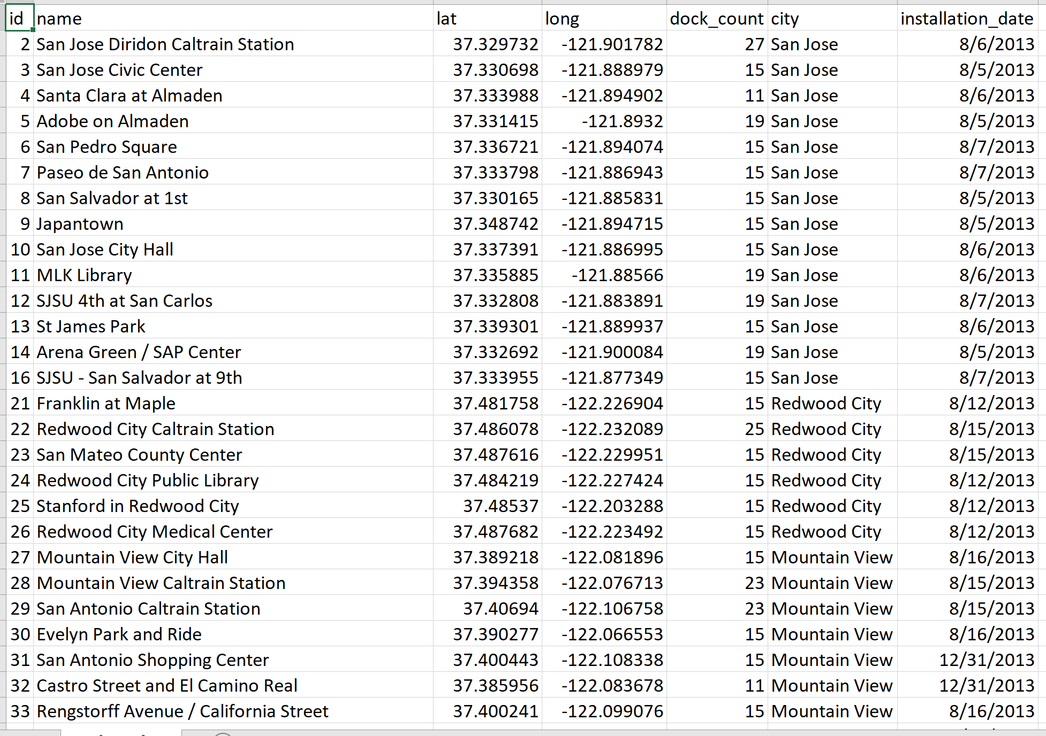

status_clean:

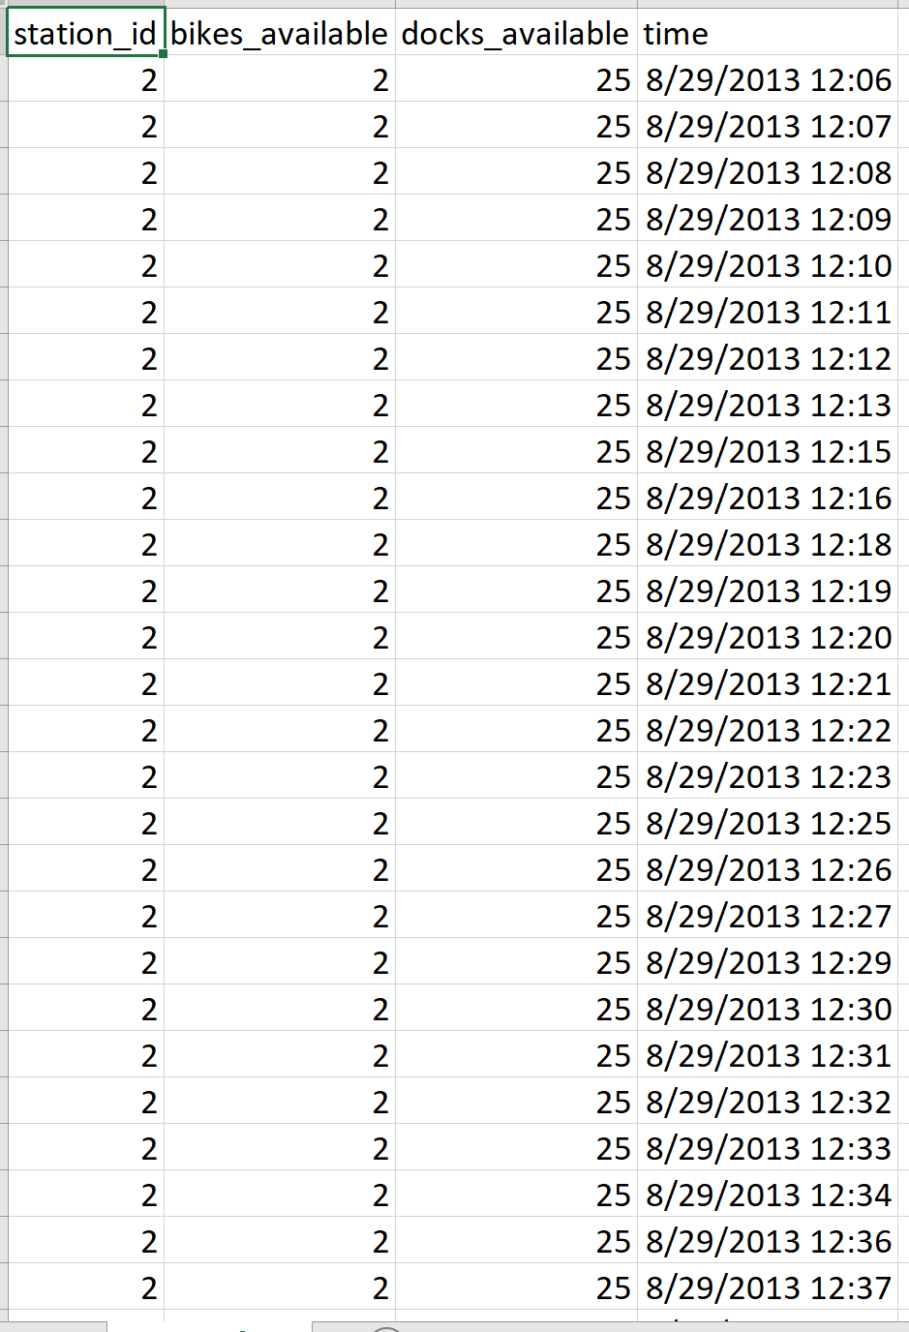

trips_clean:

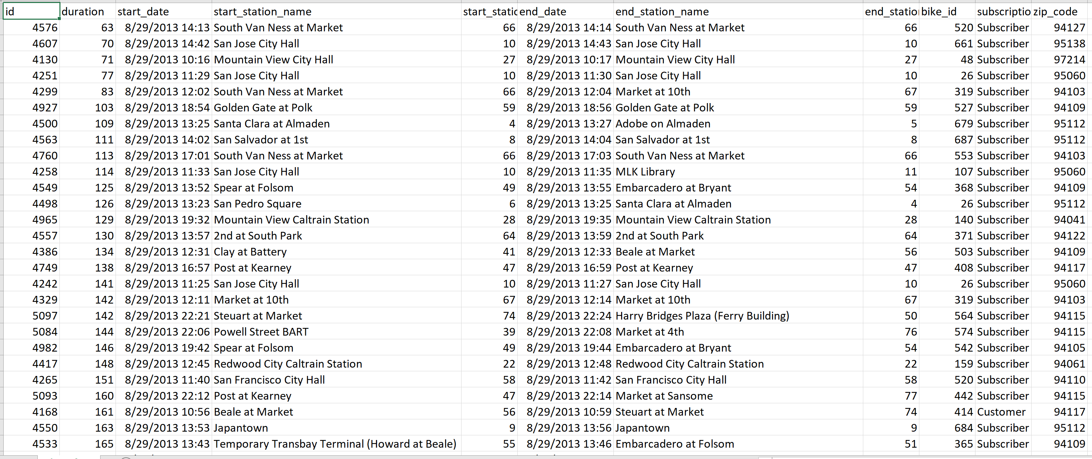

weather_clean:

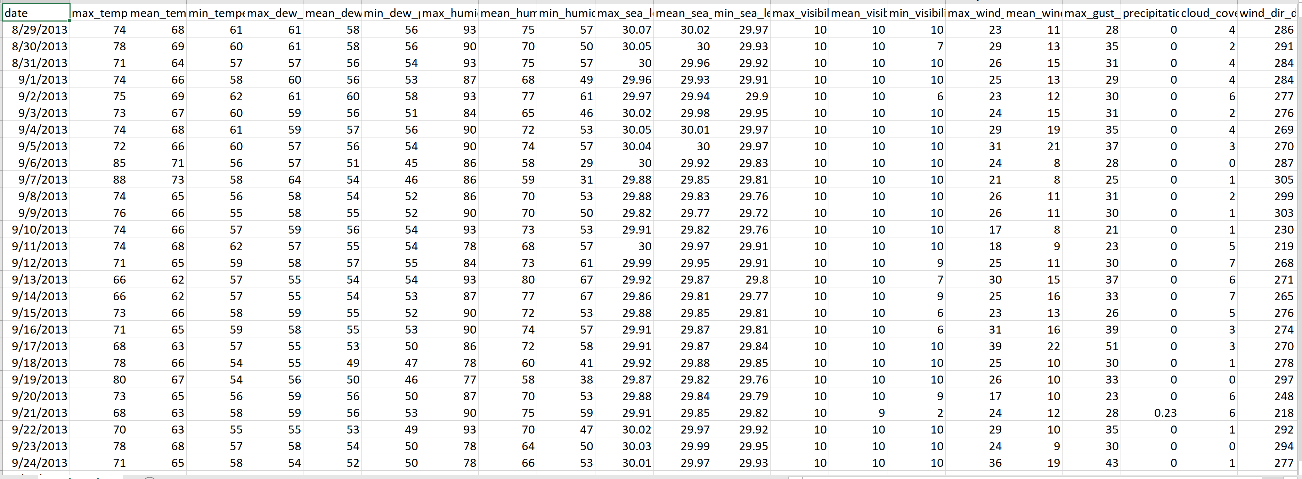

questions_clean:

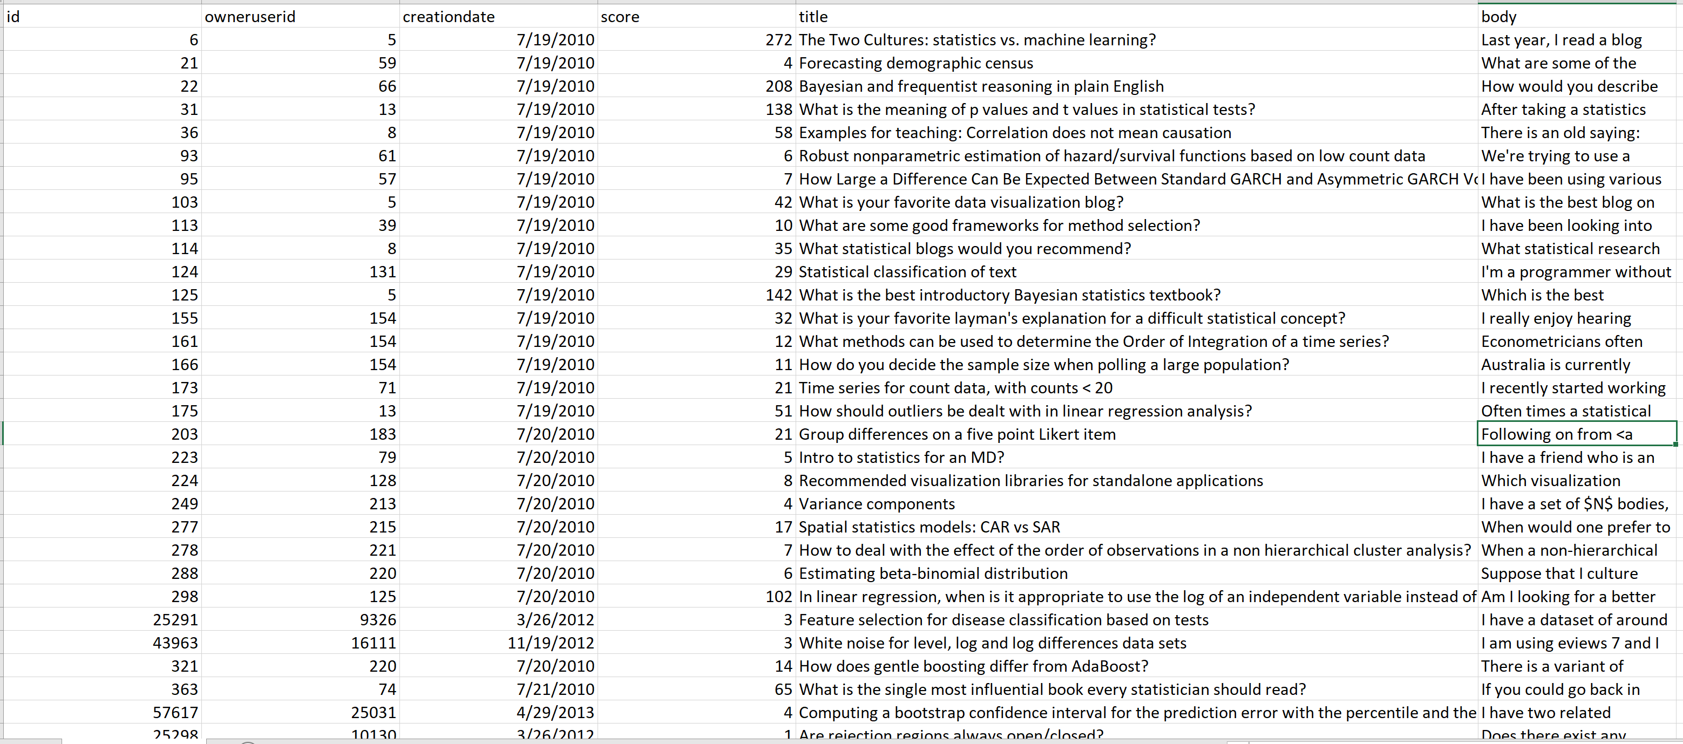

answers_clean:

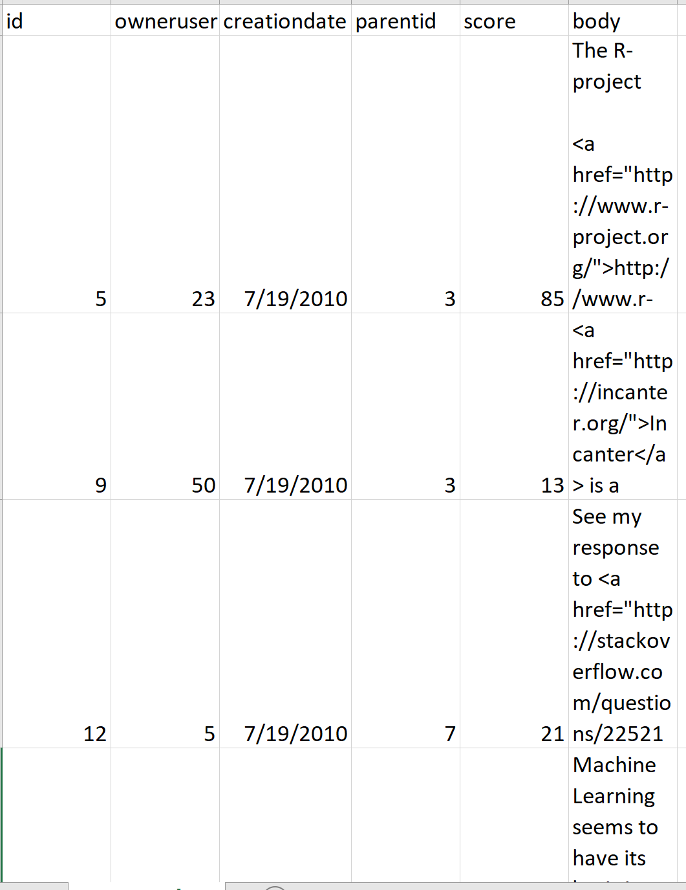

patients_clean:

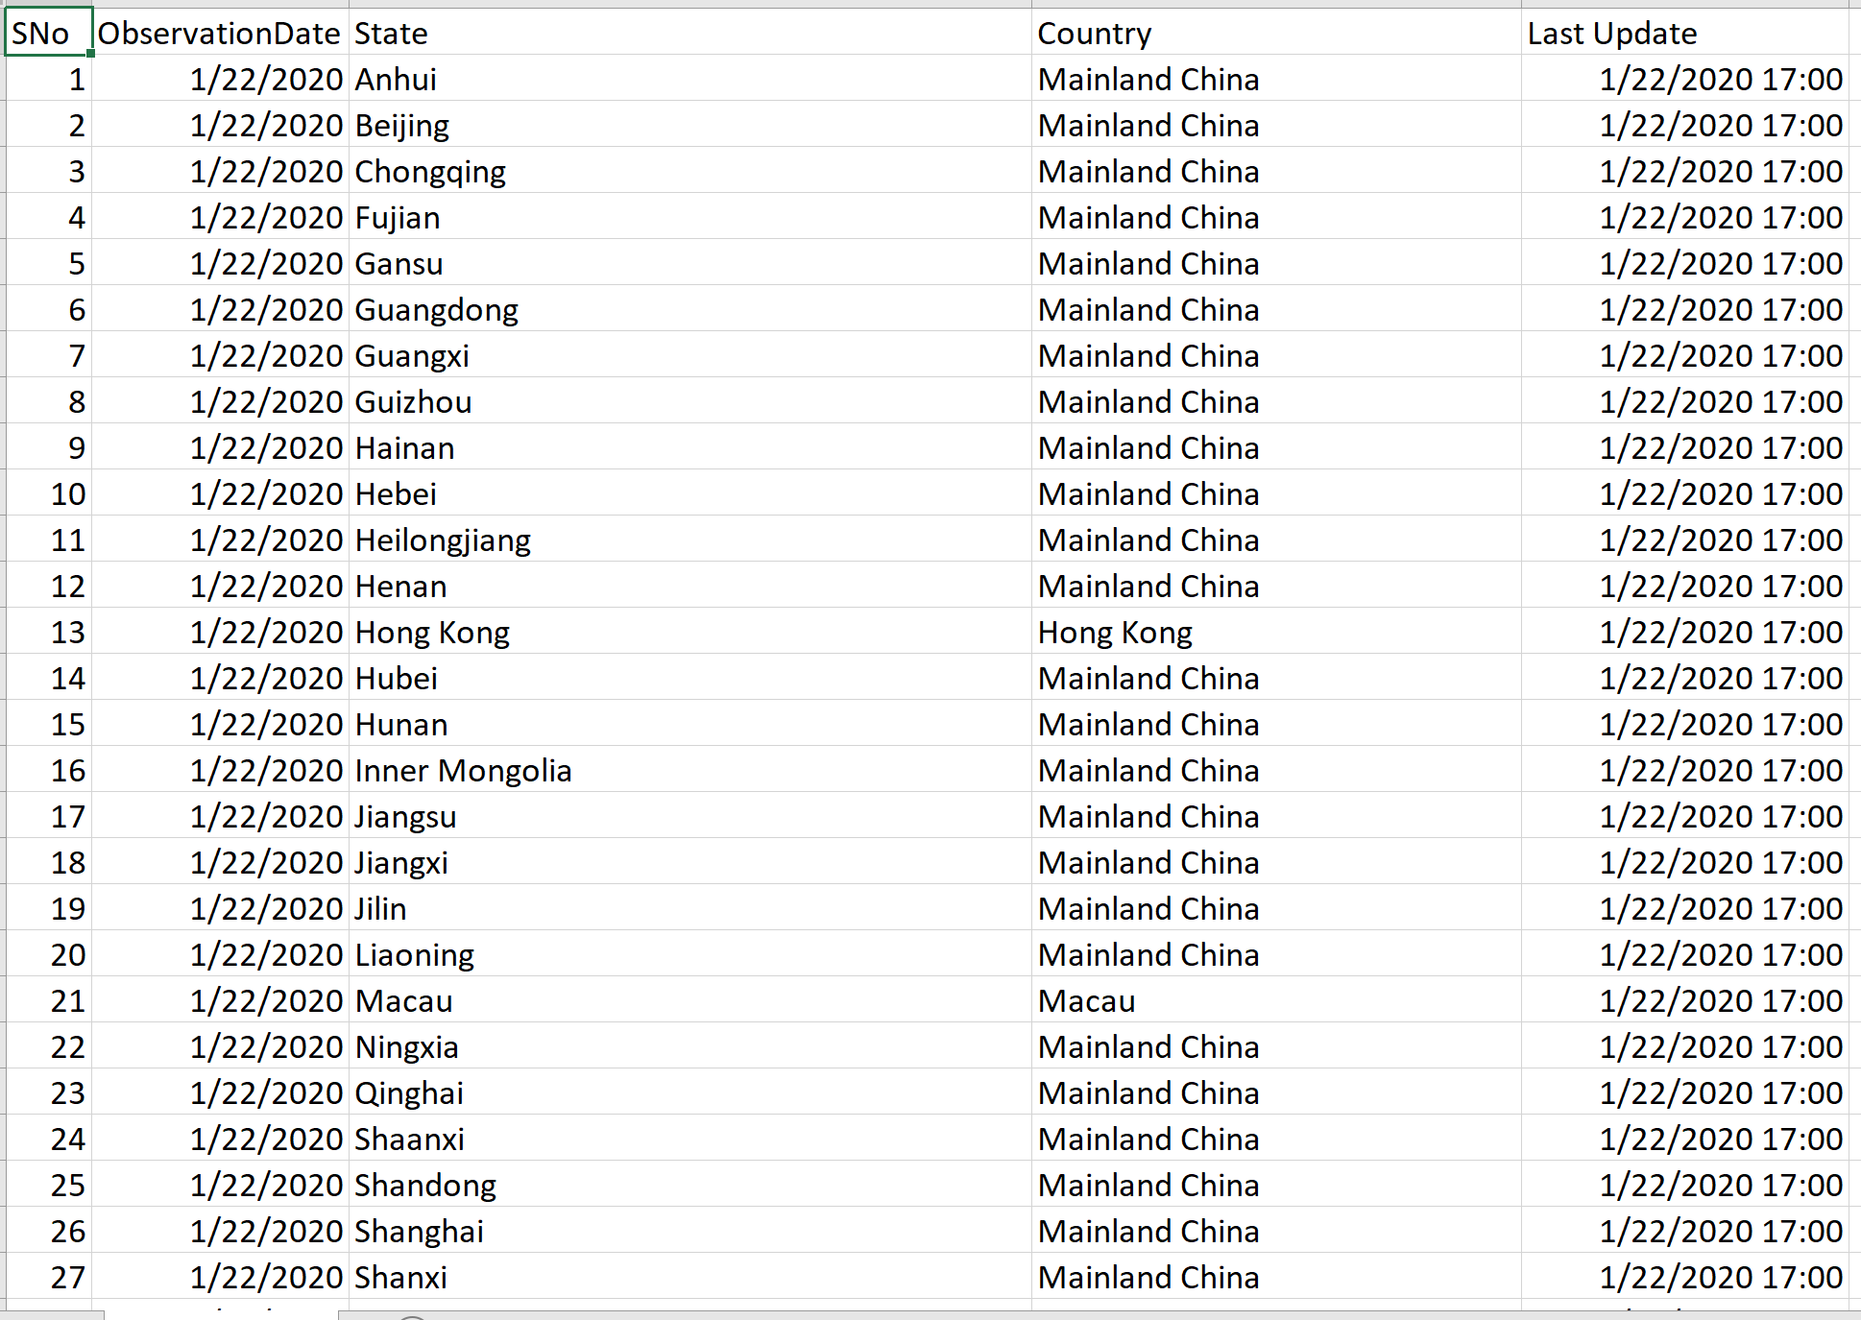

confirmed_cases:

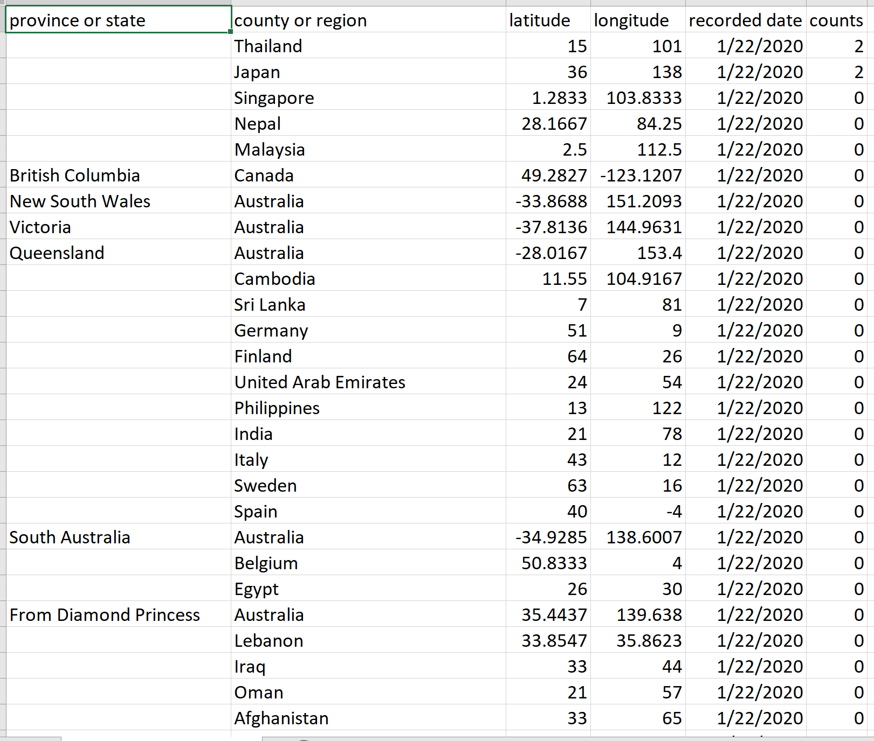

death_cases_clean:

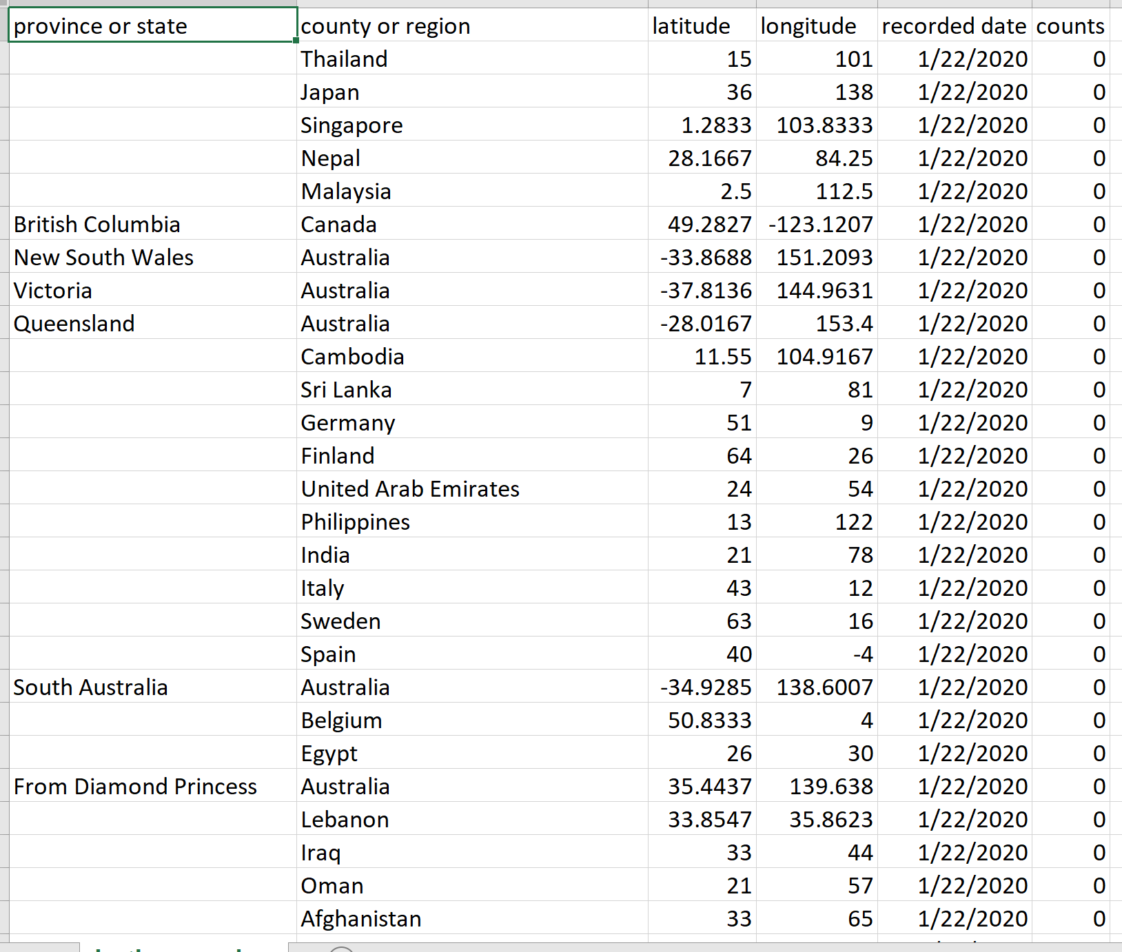

recovered_cases_clean:

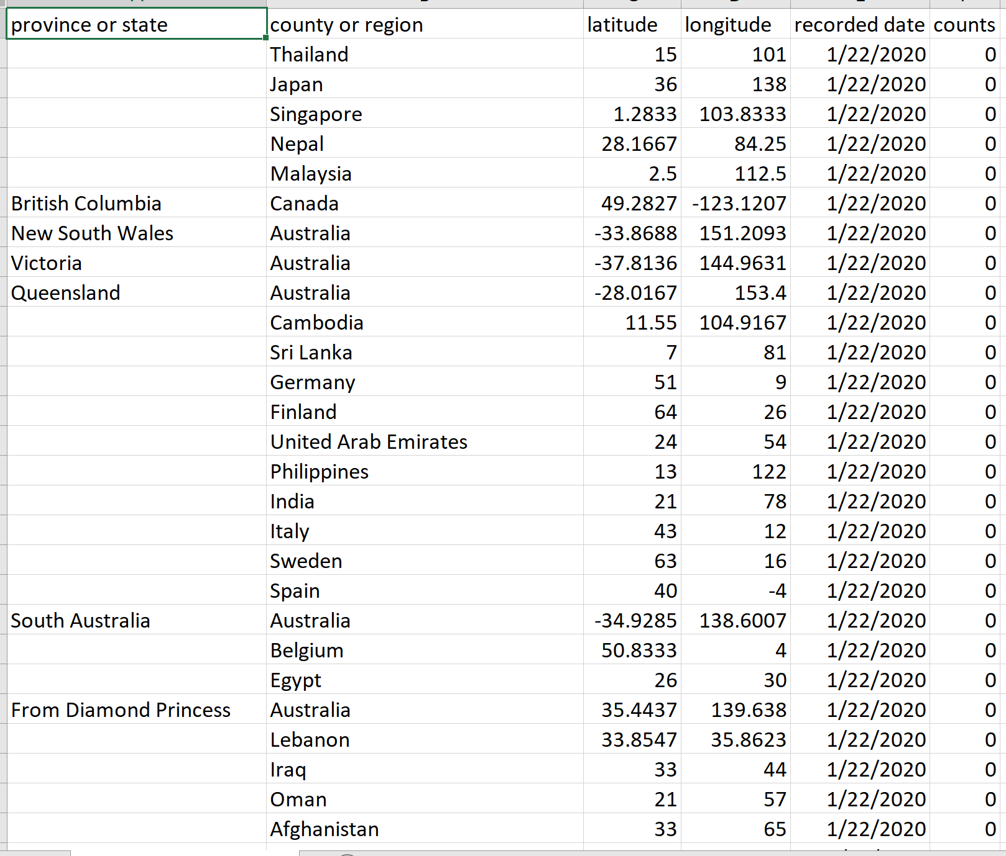

tags_clean:

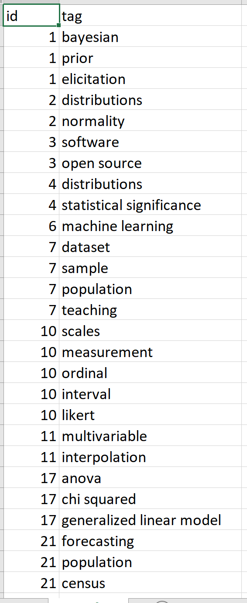

Python script to load MySQL DB:

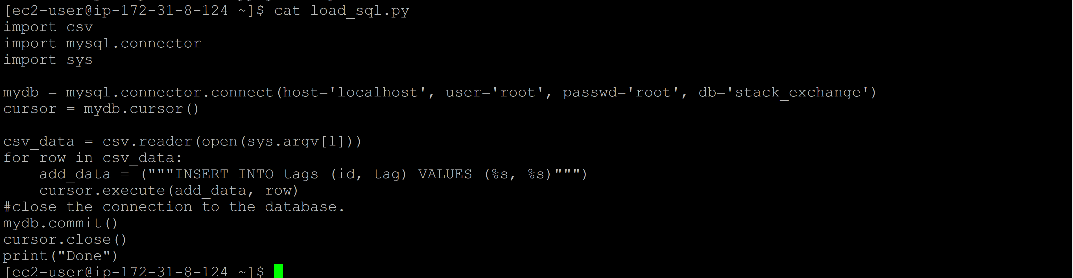

MySQL DB Data:

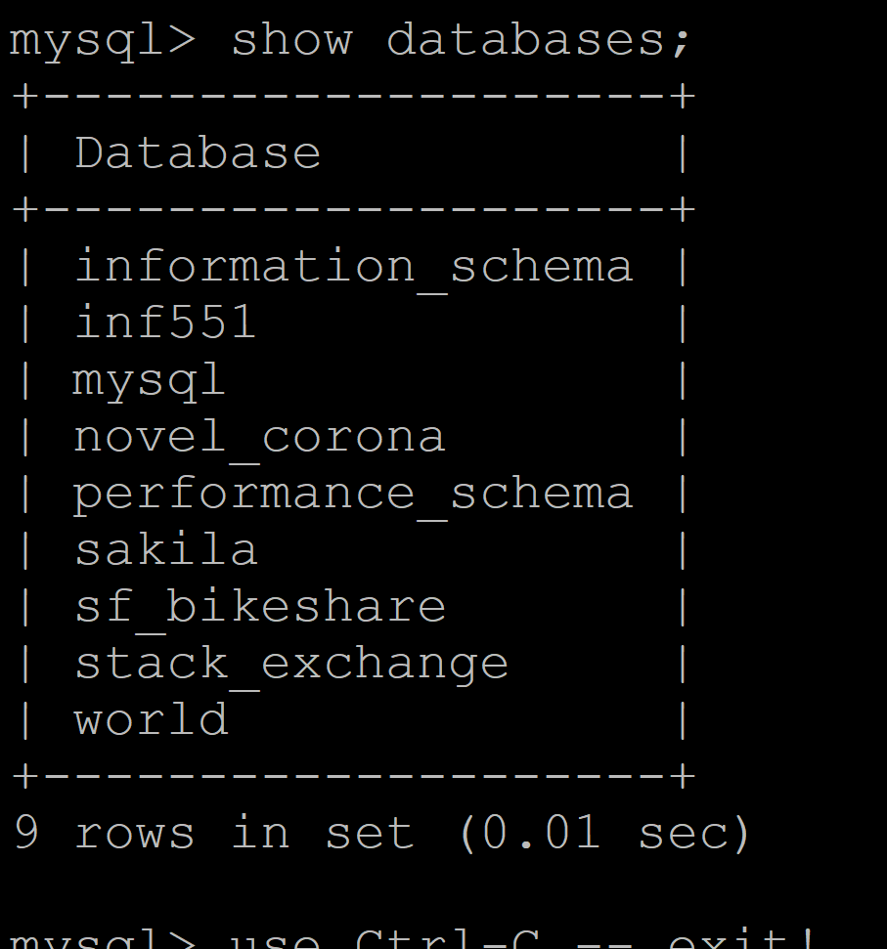

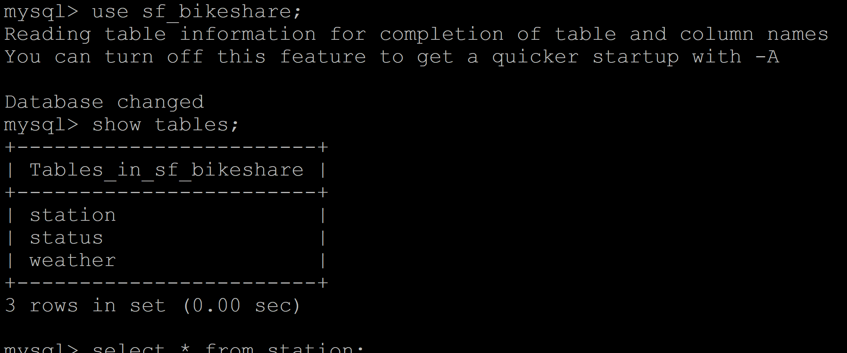

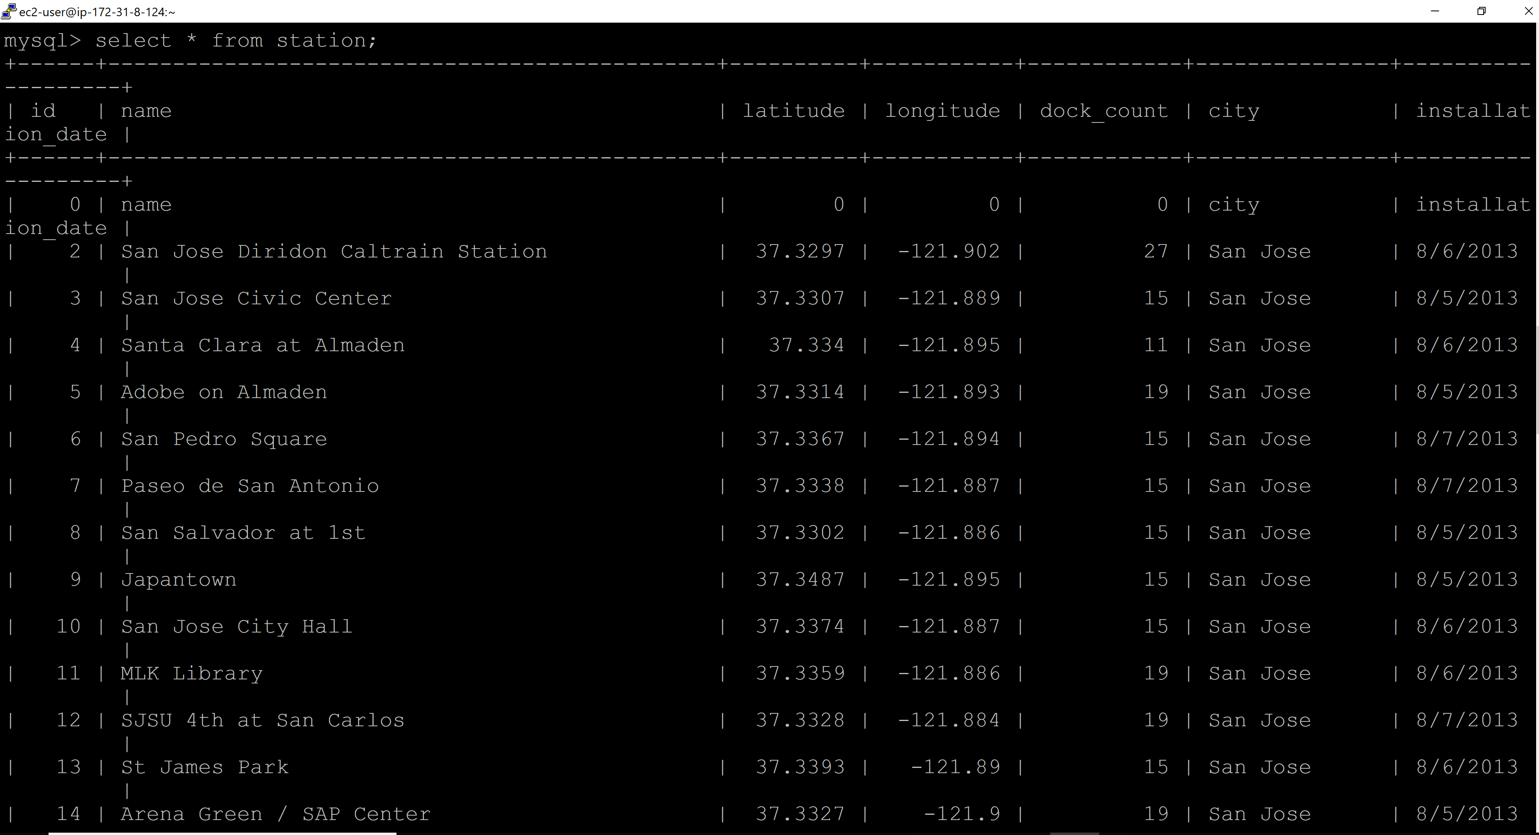

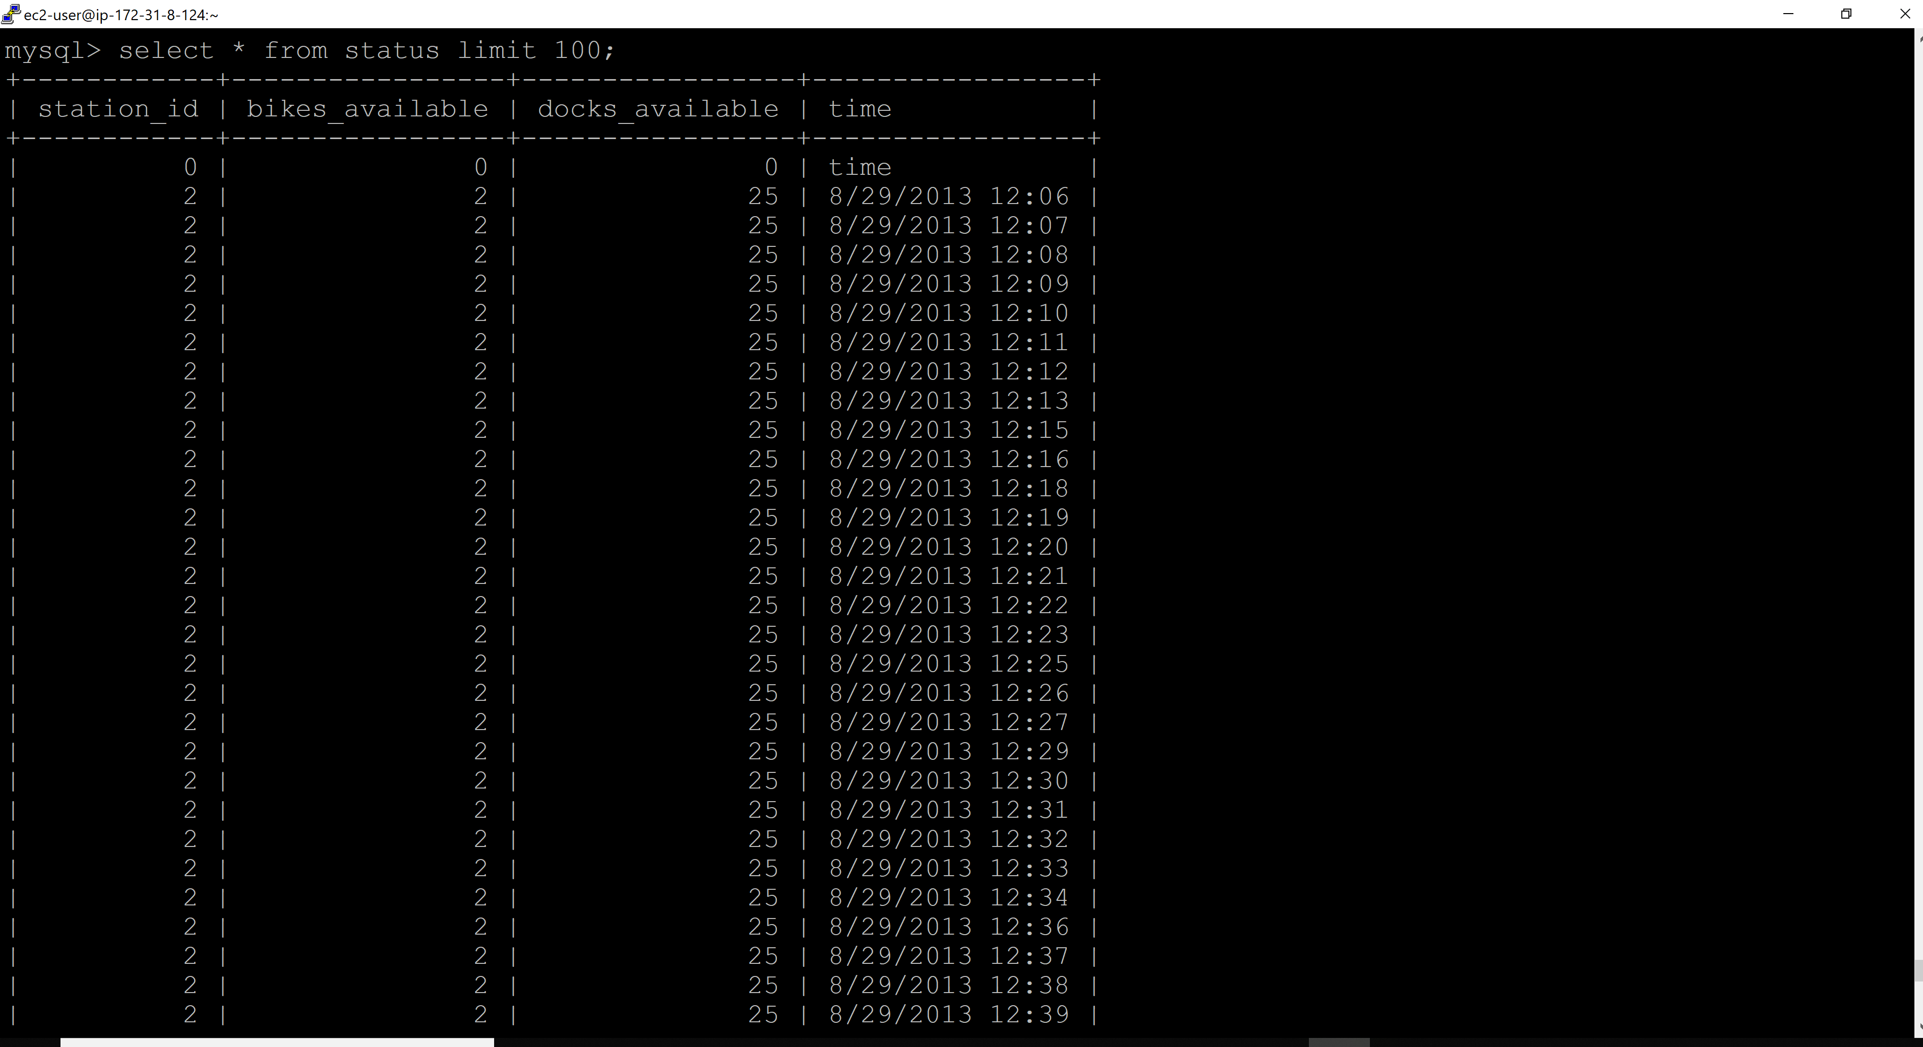

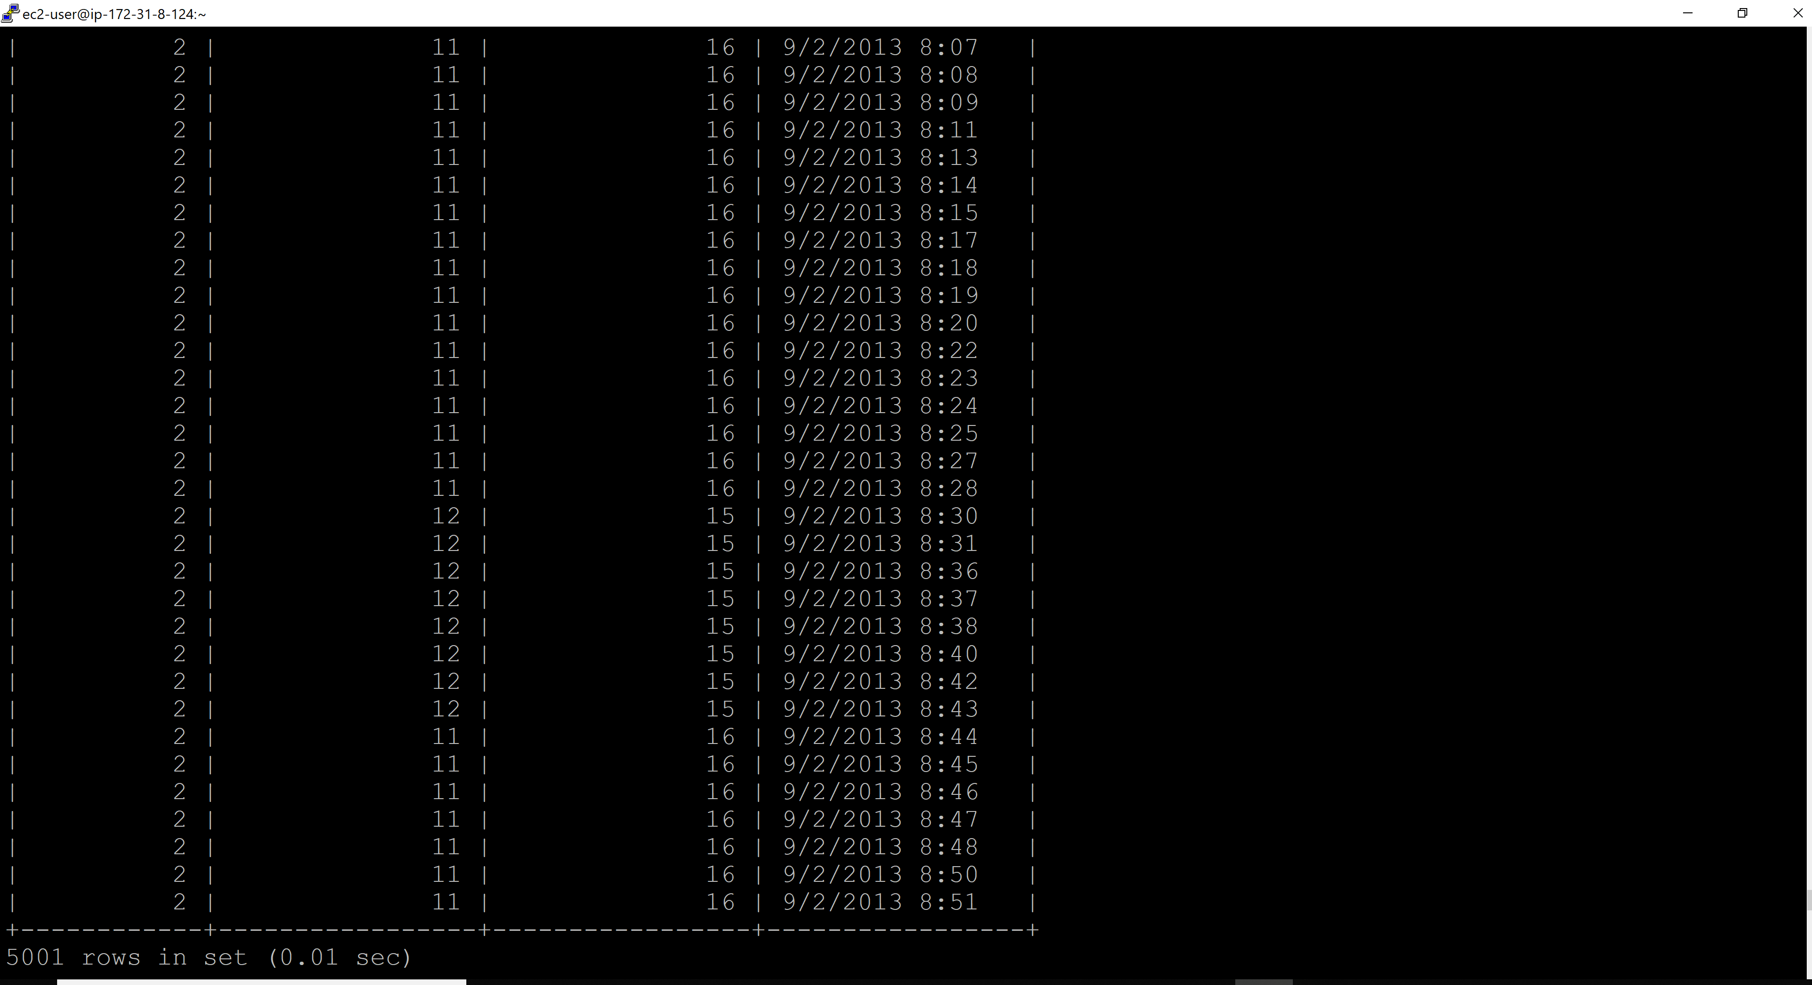

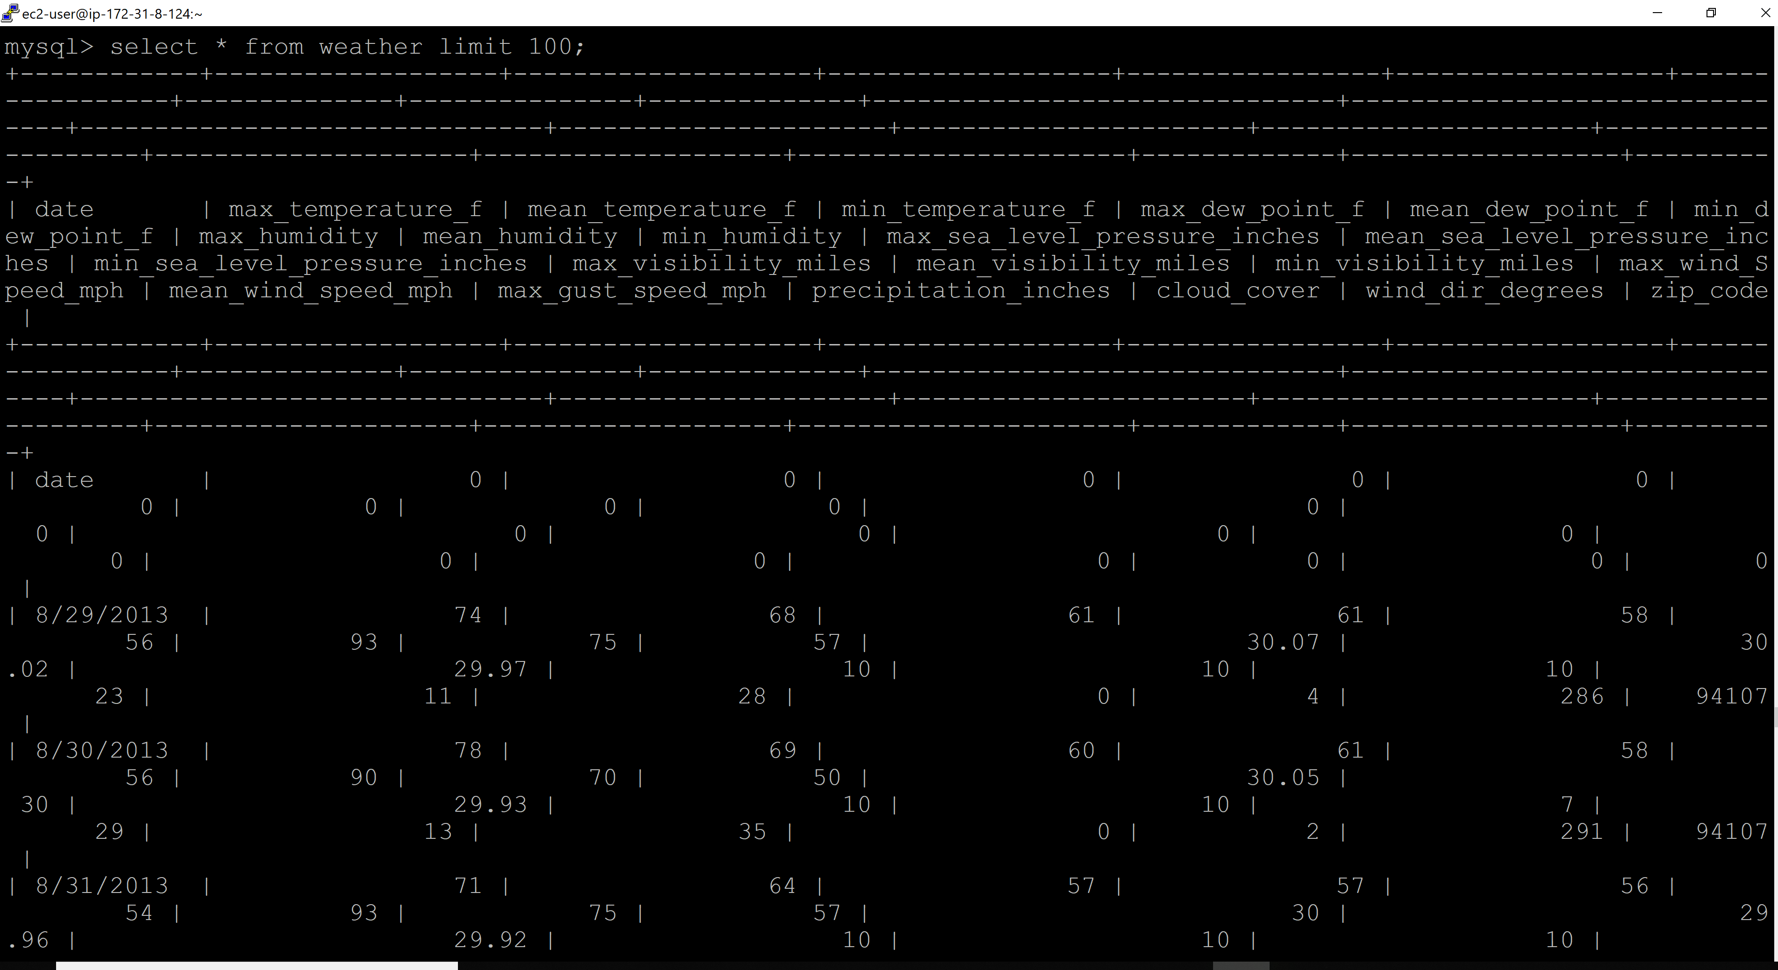

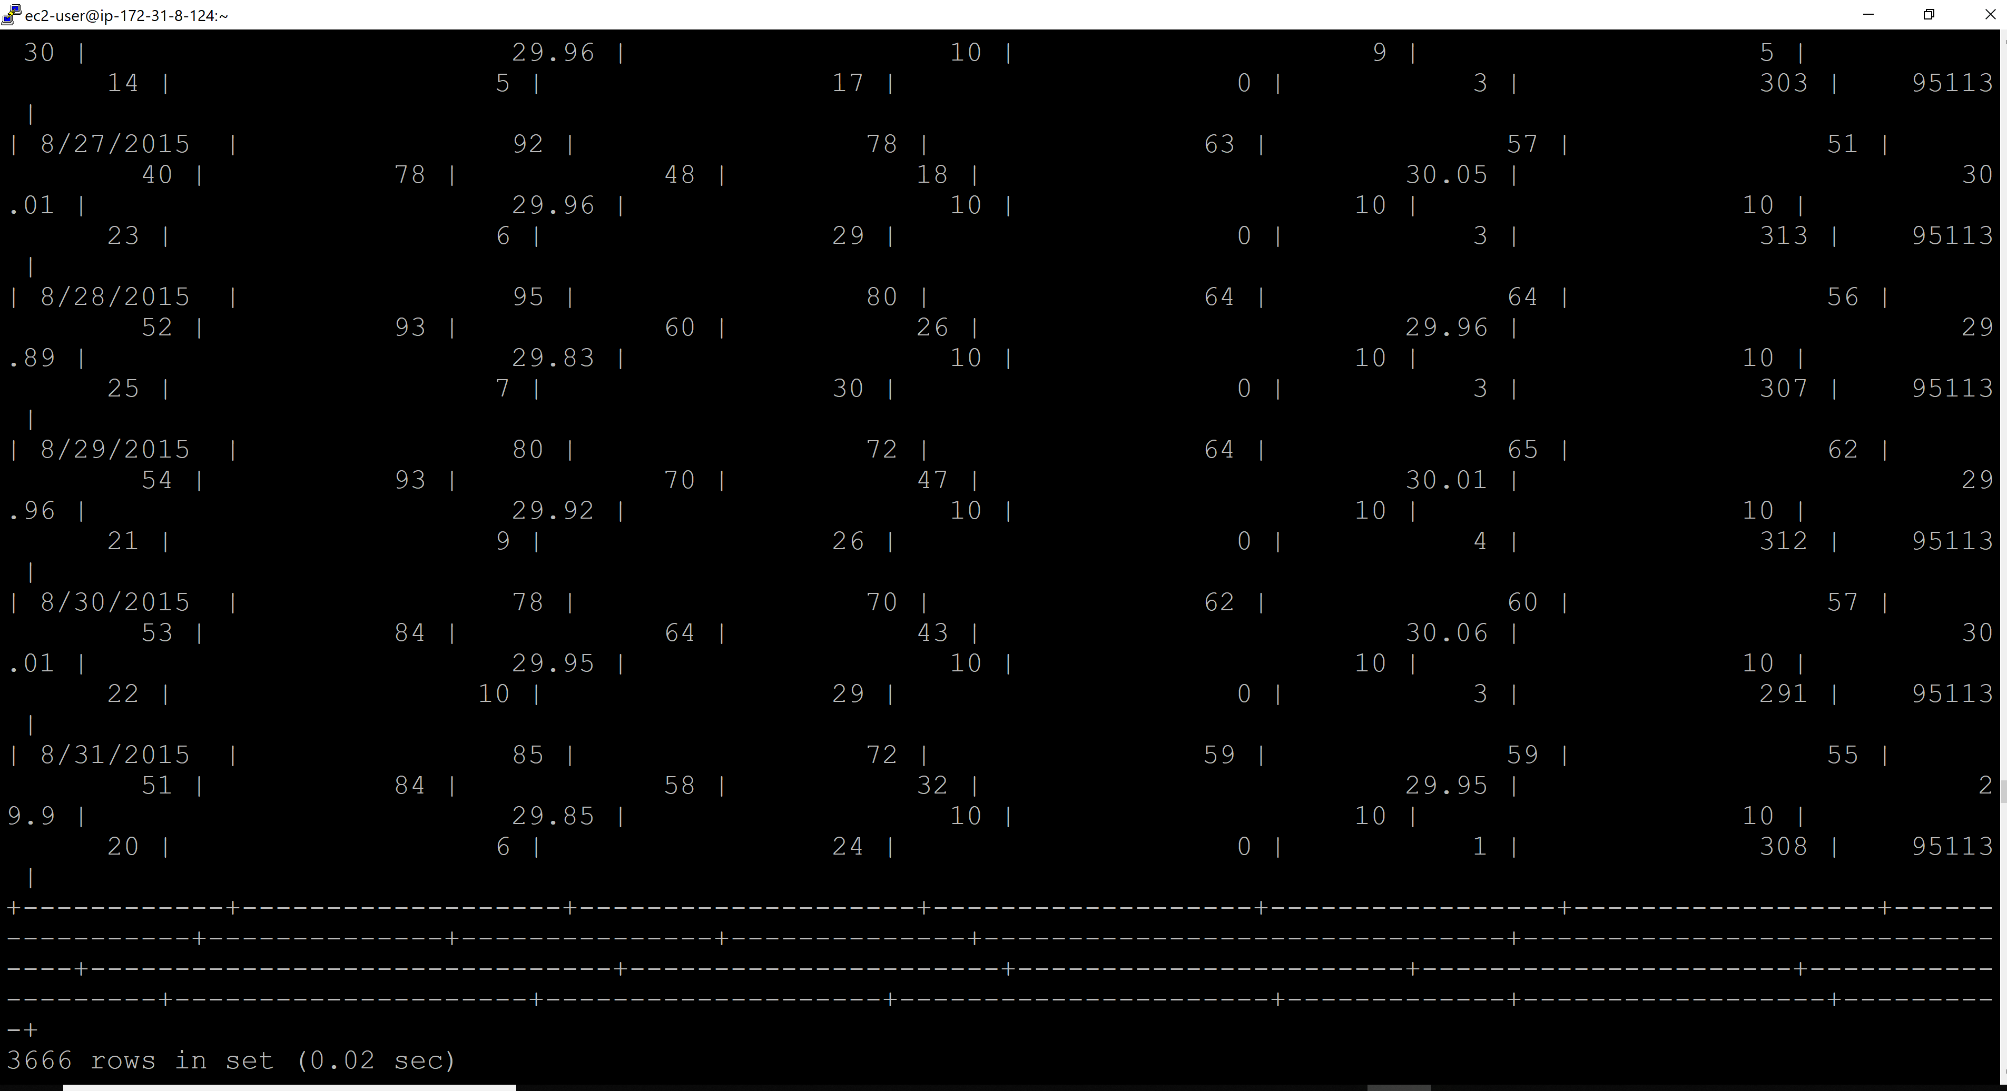

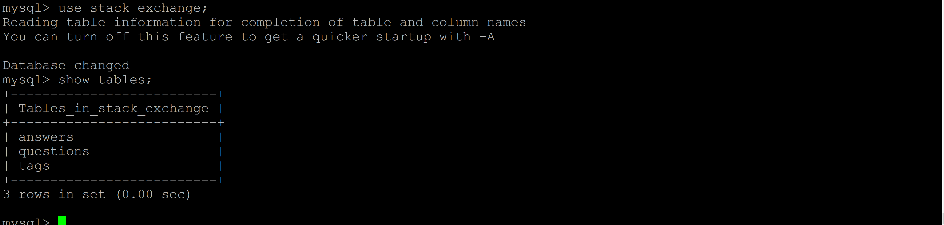

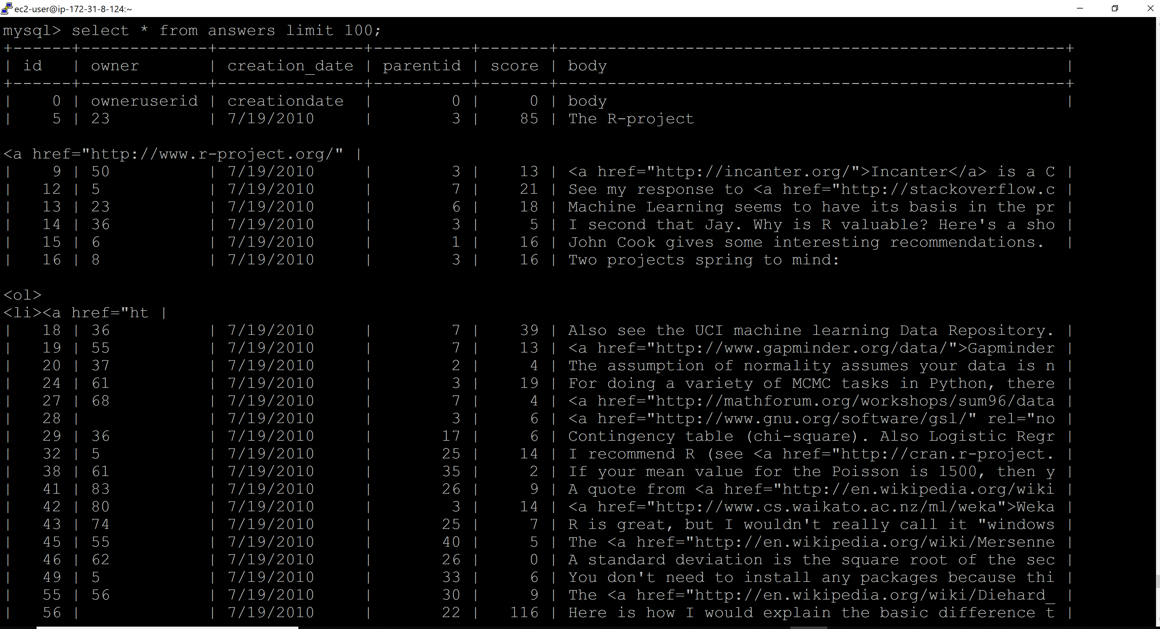

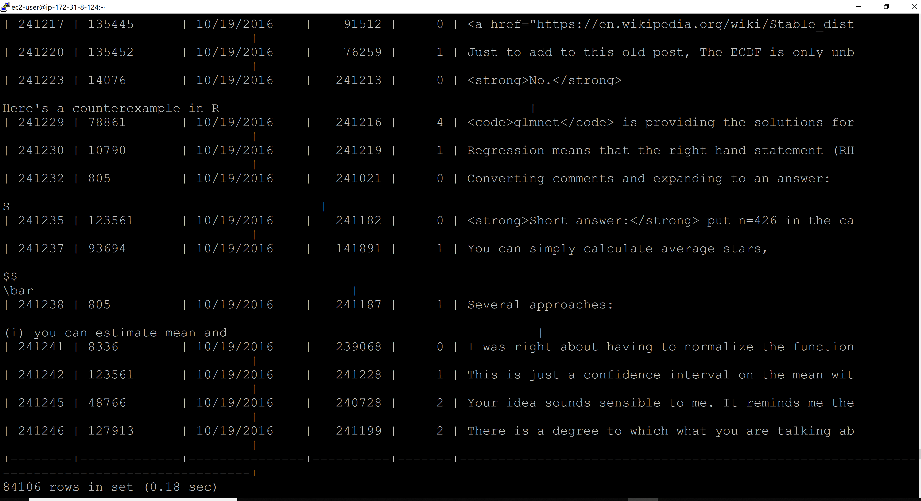

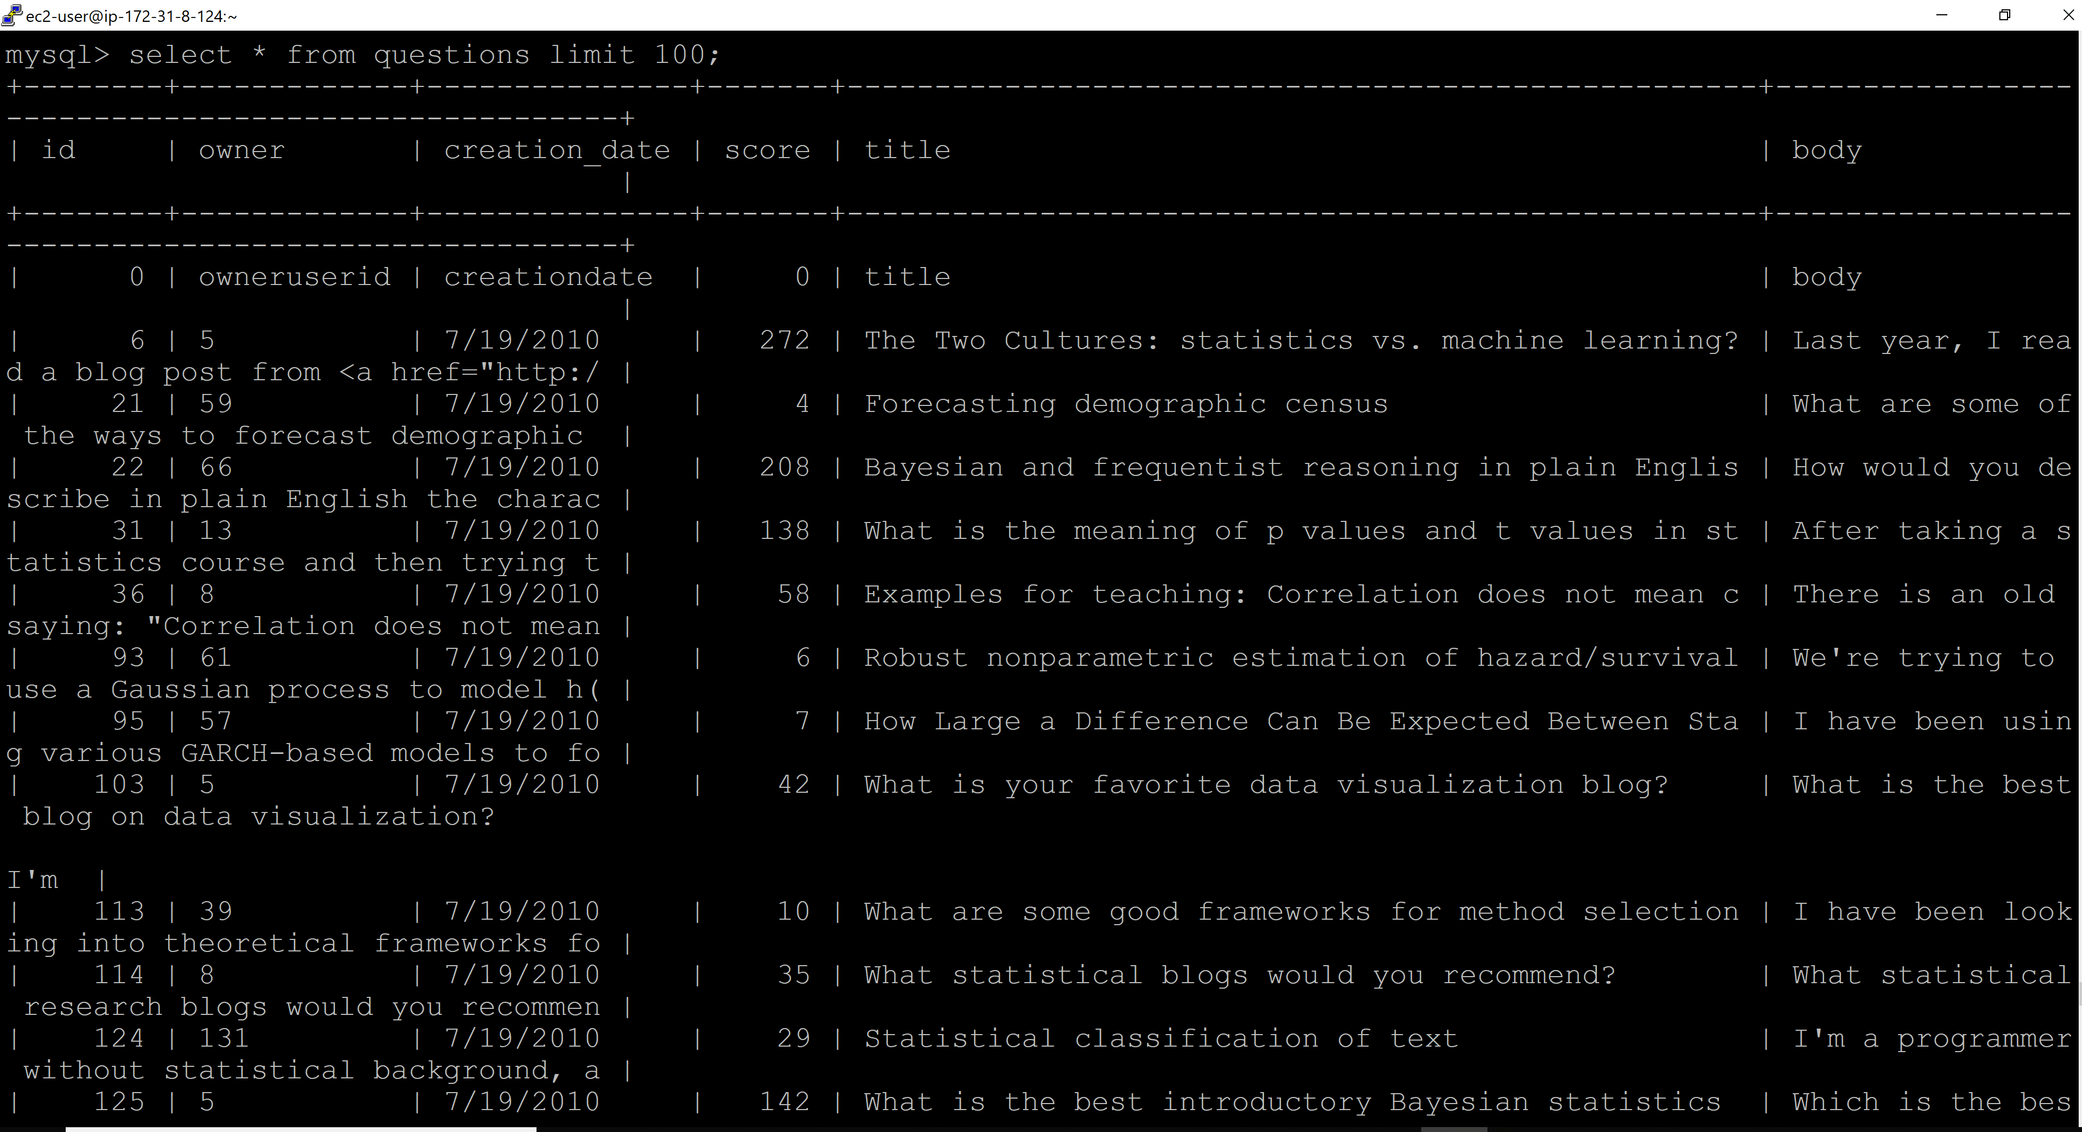

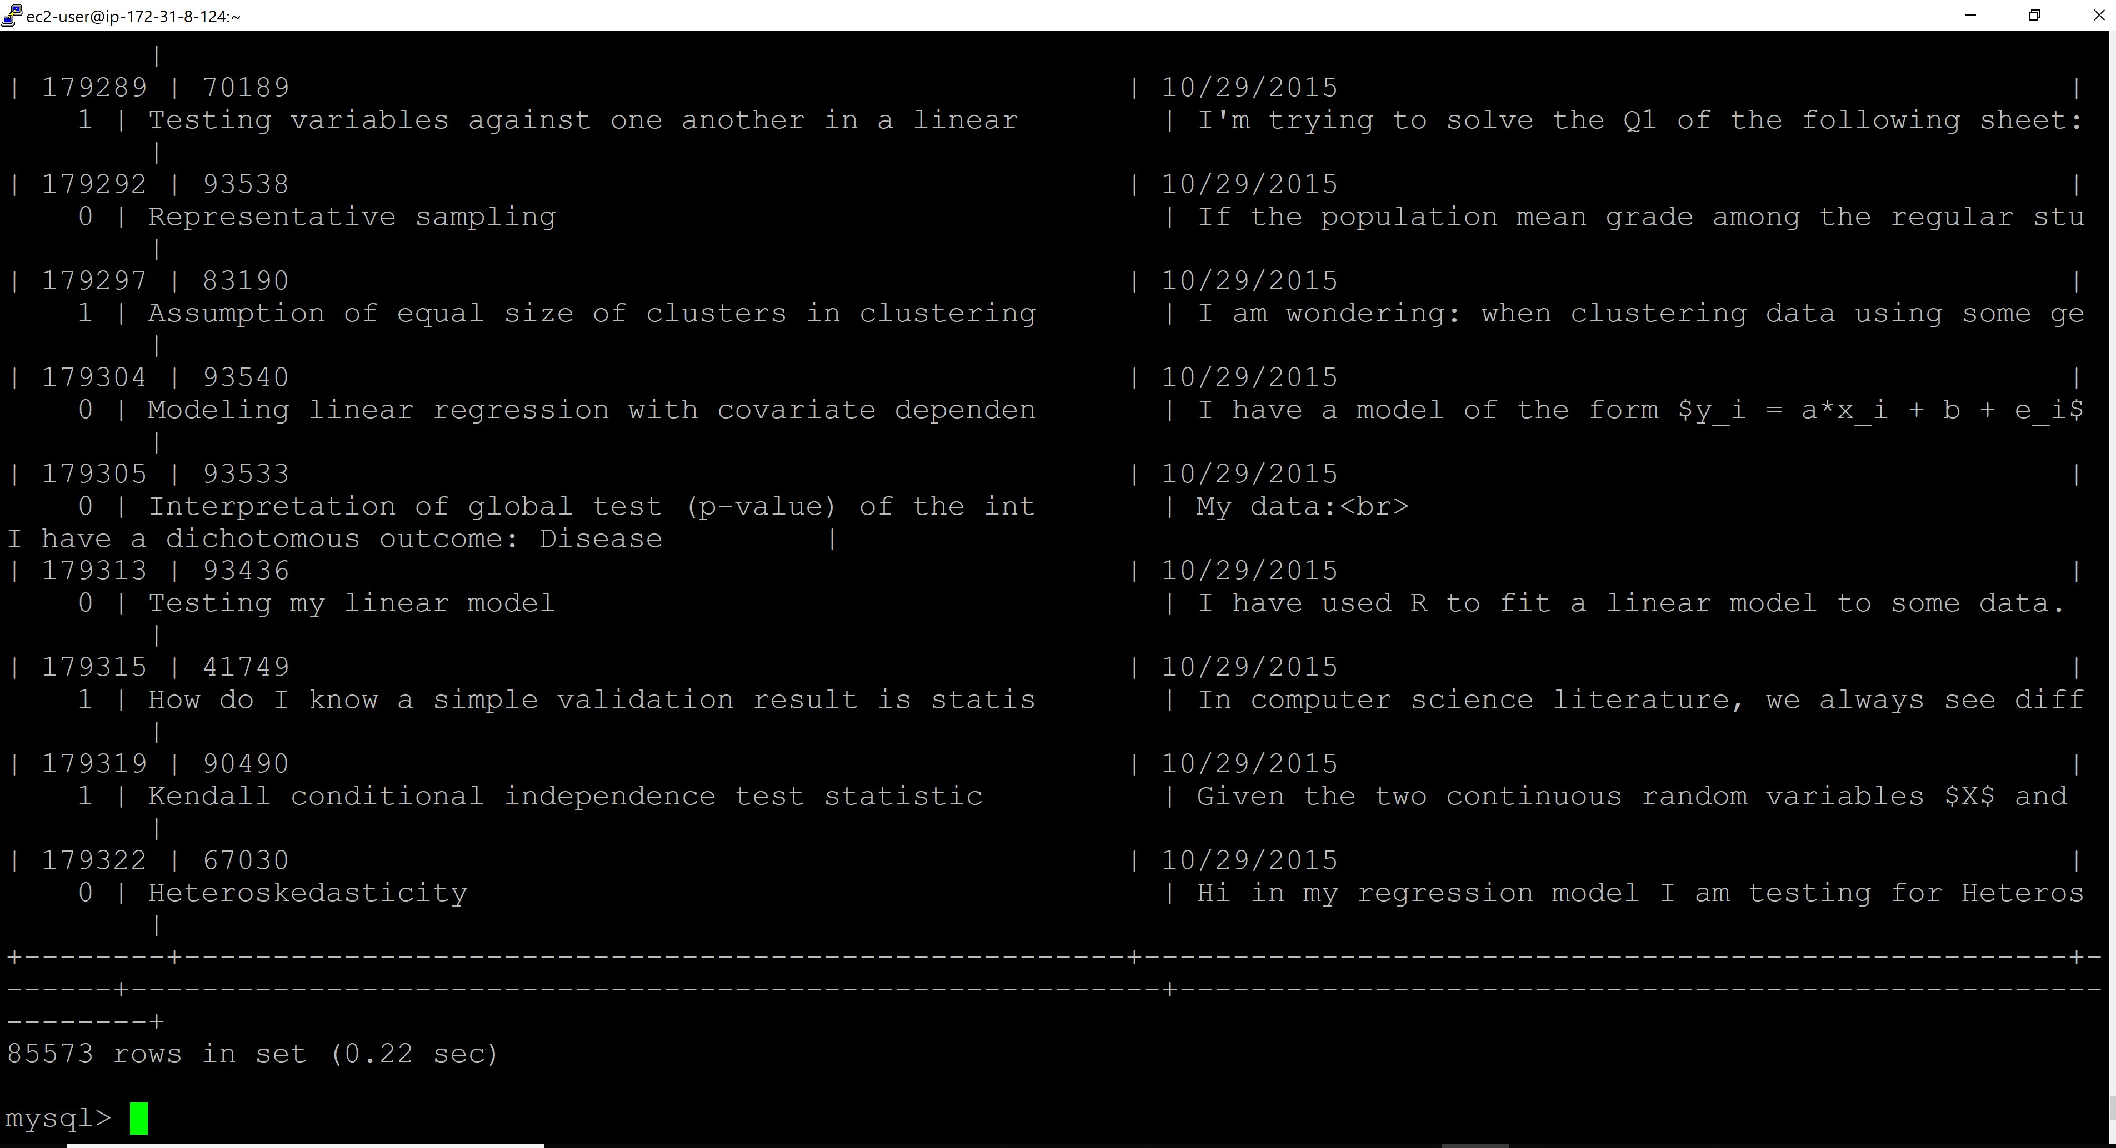

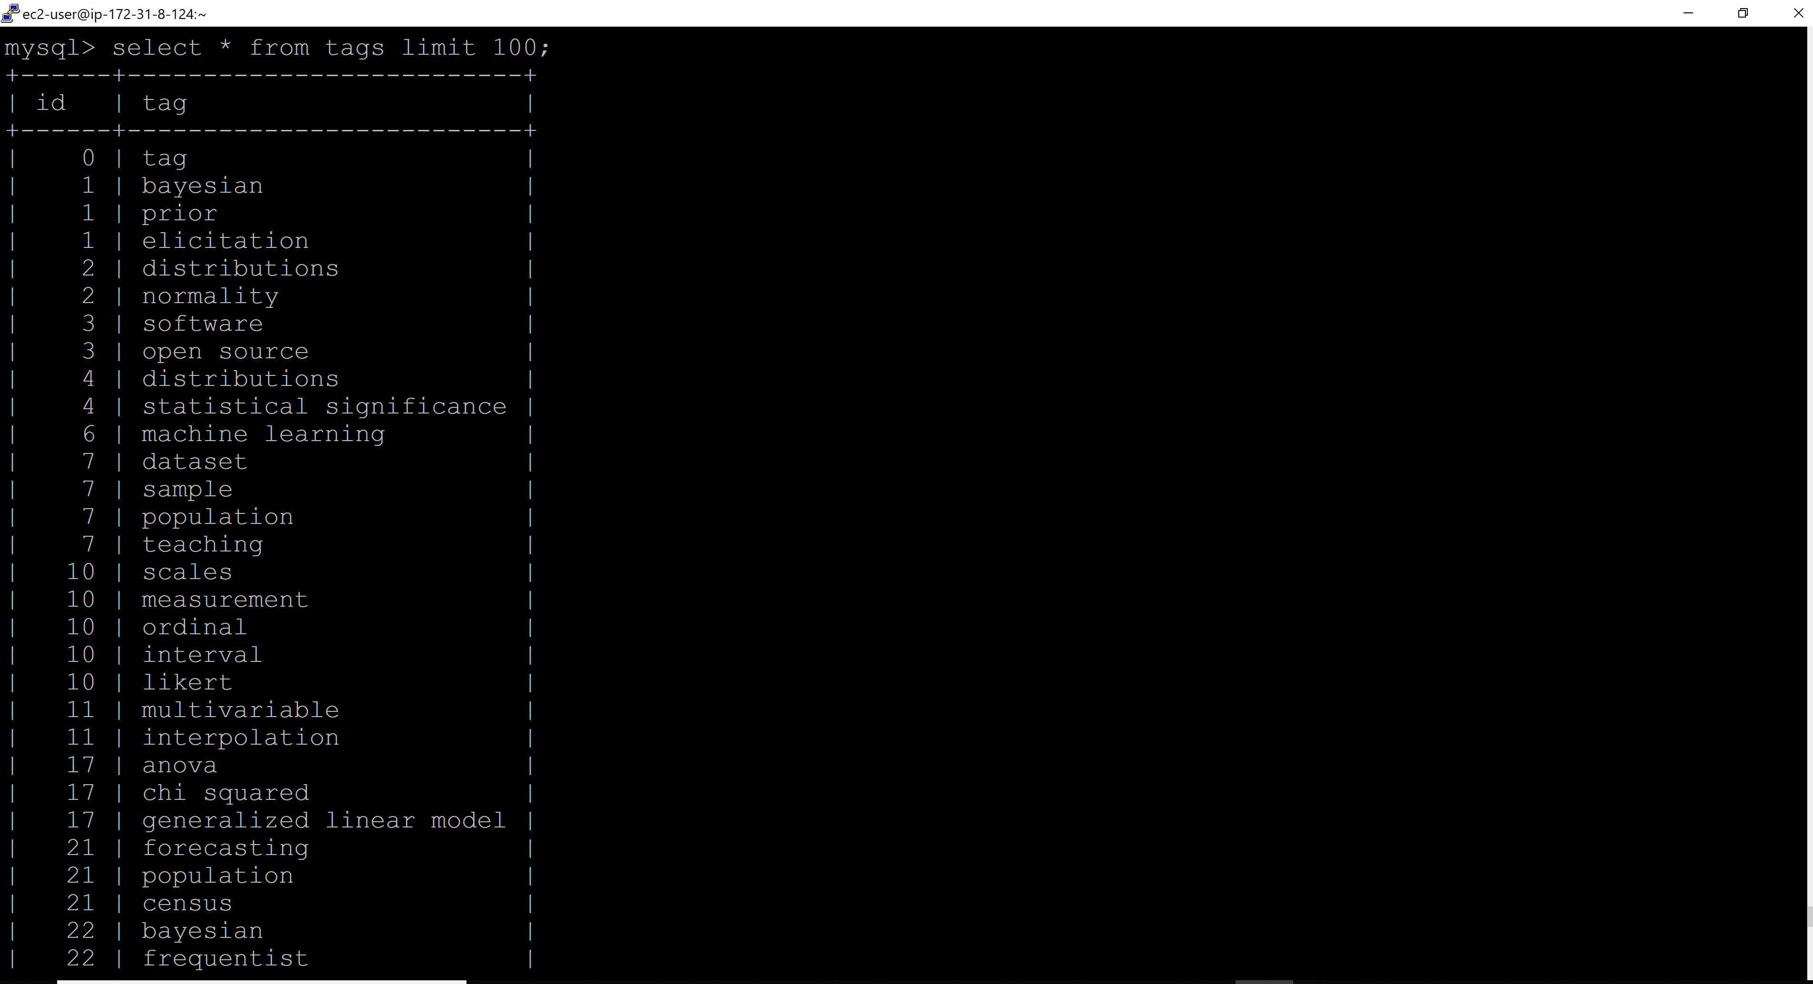

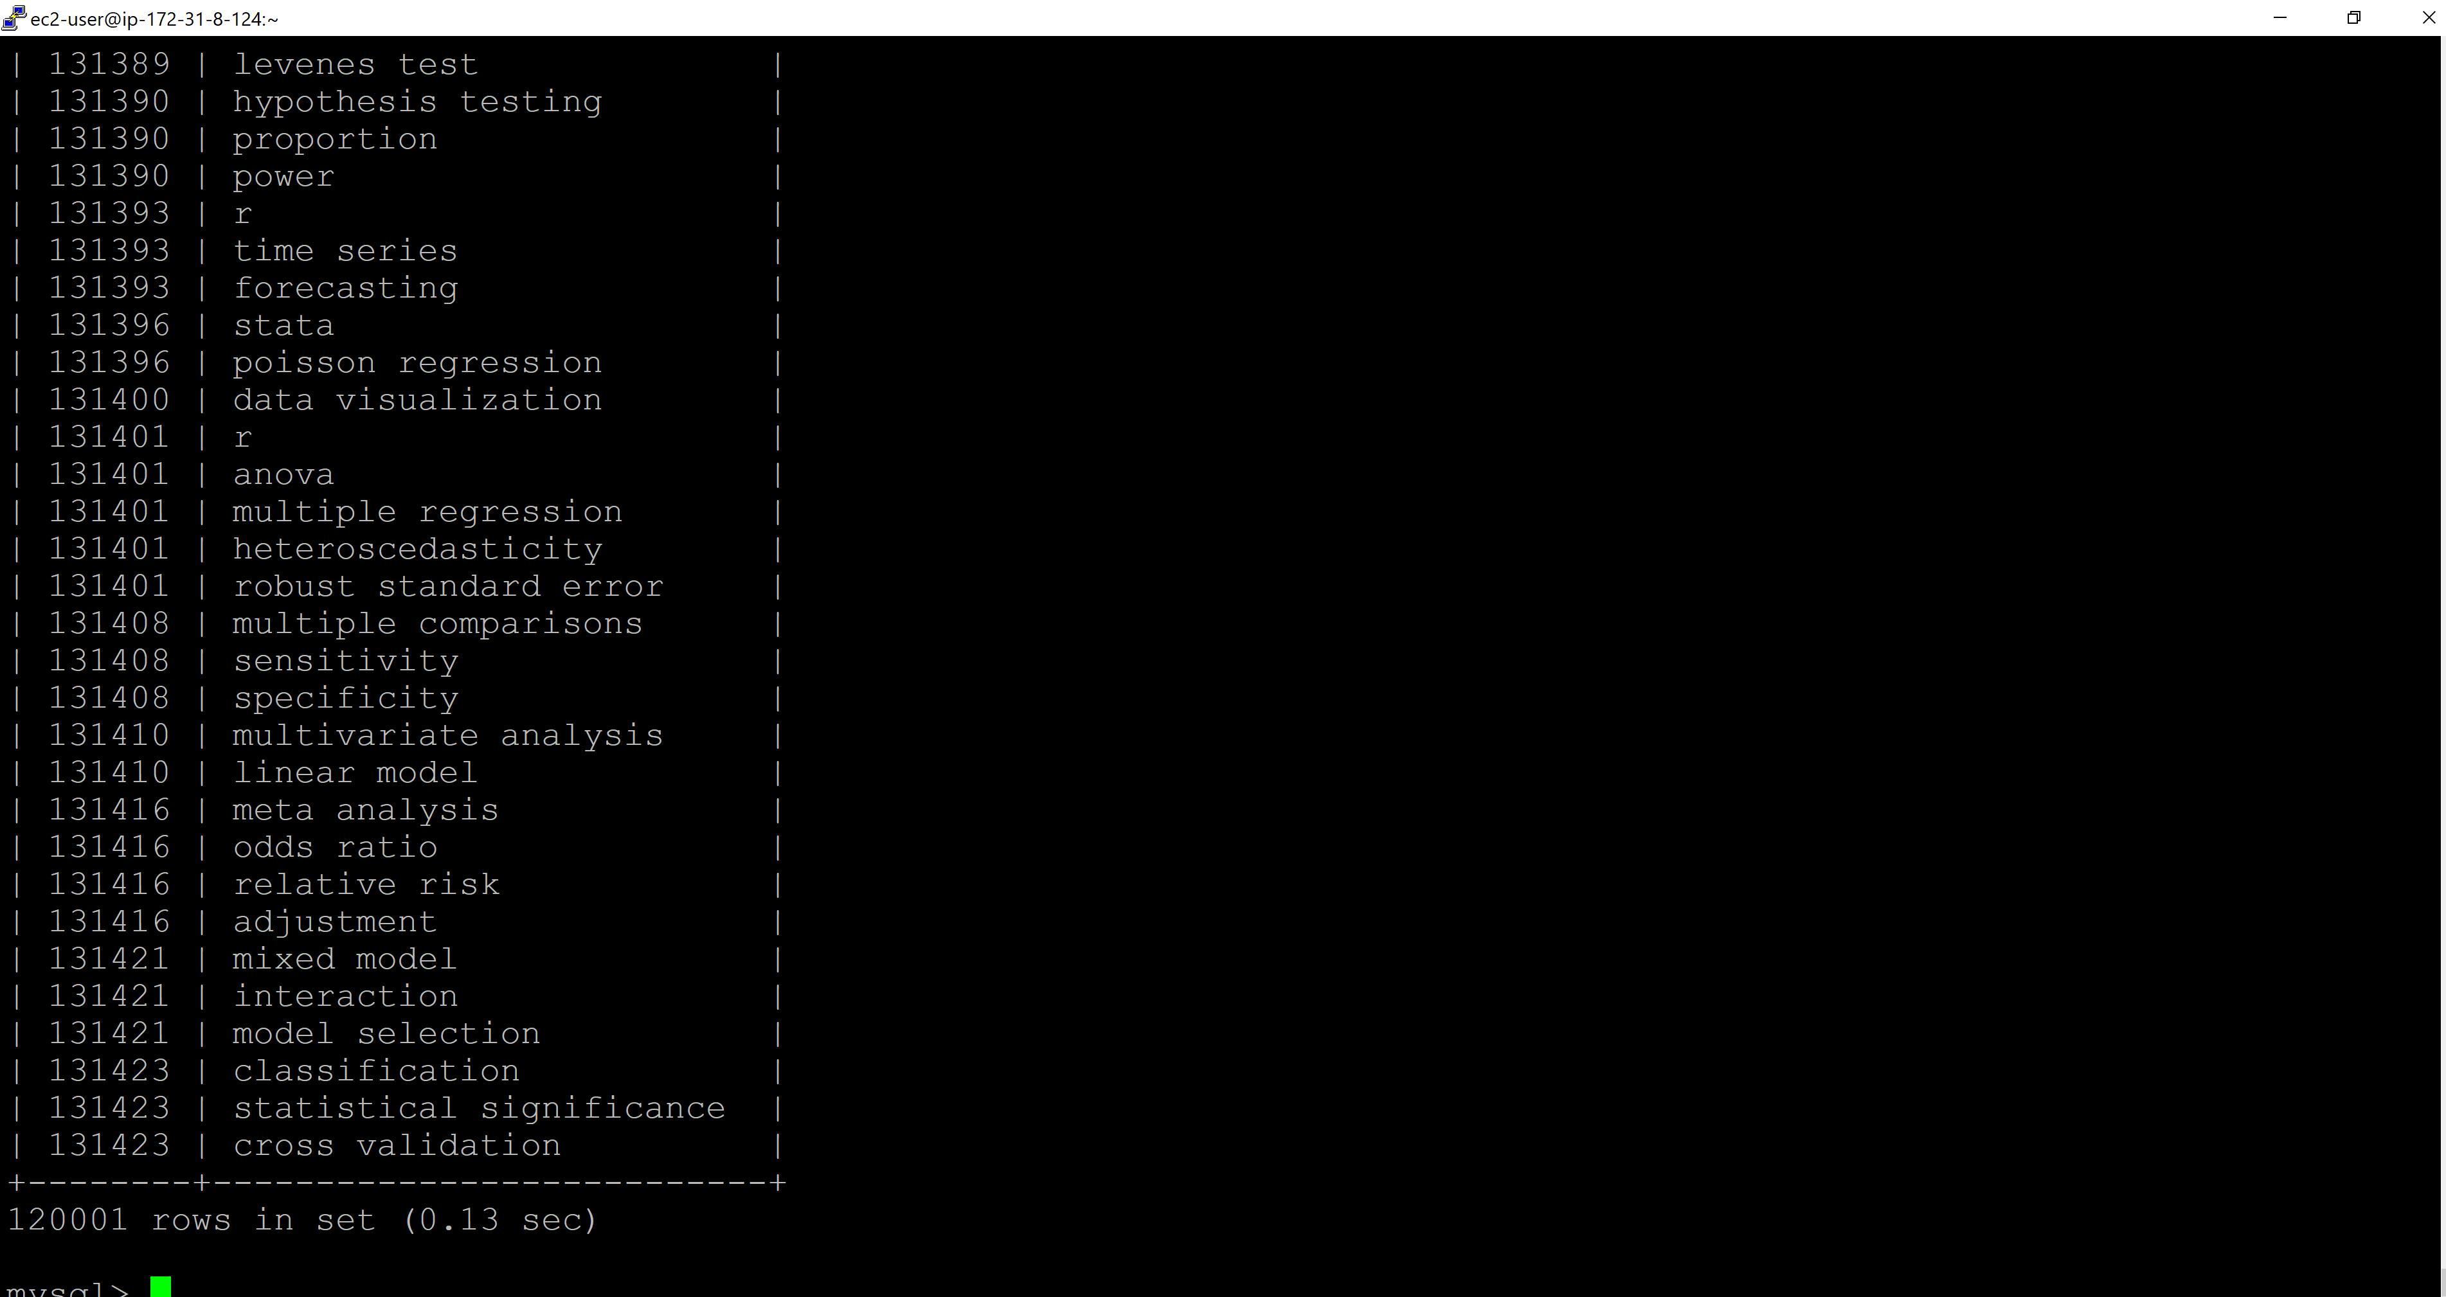

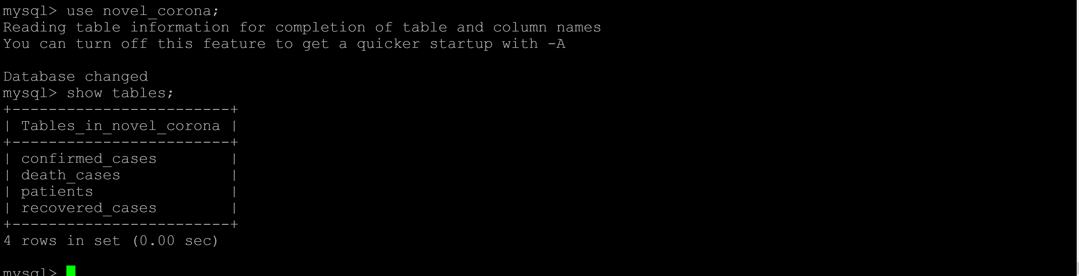

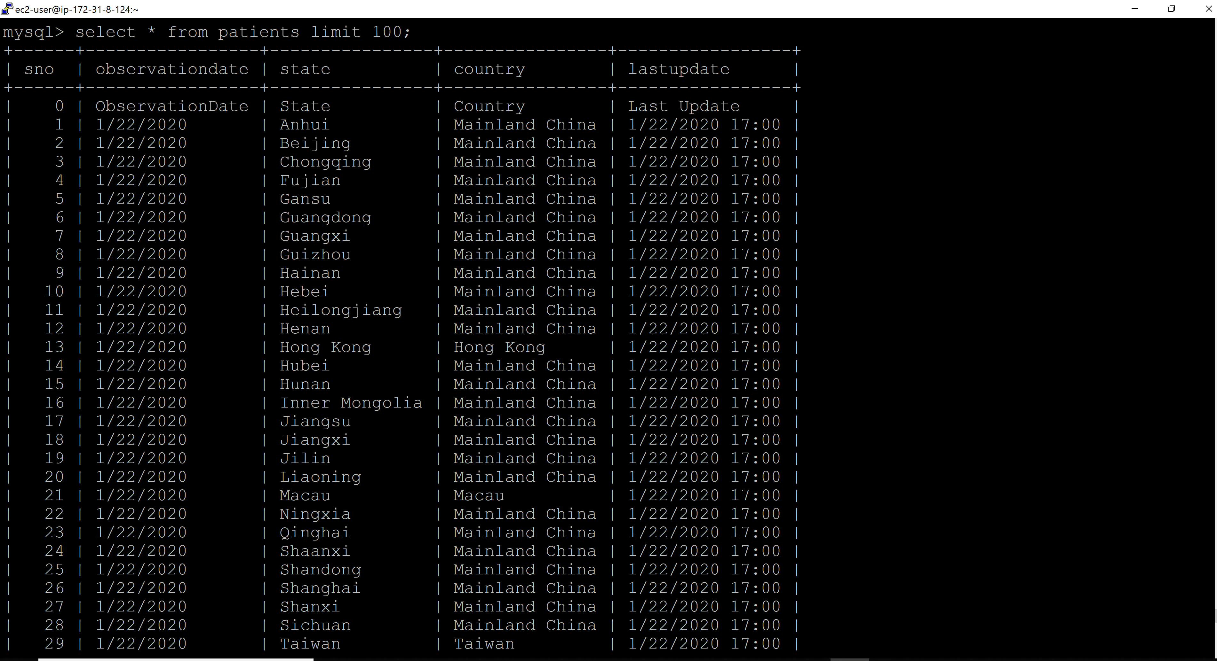

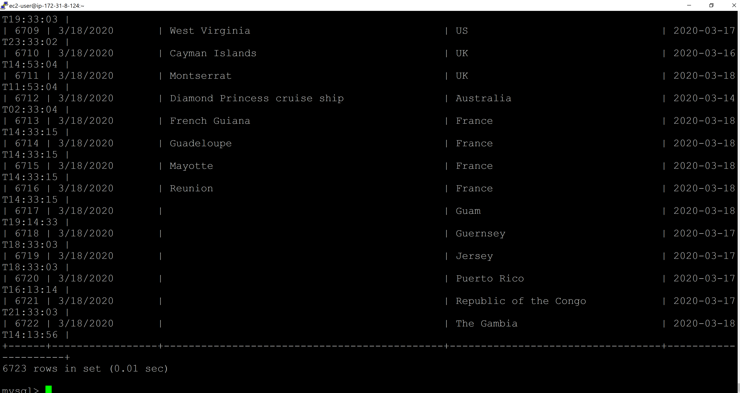

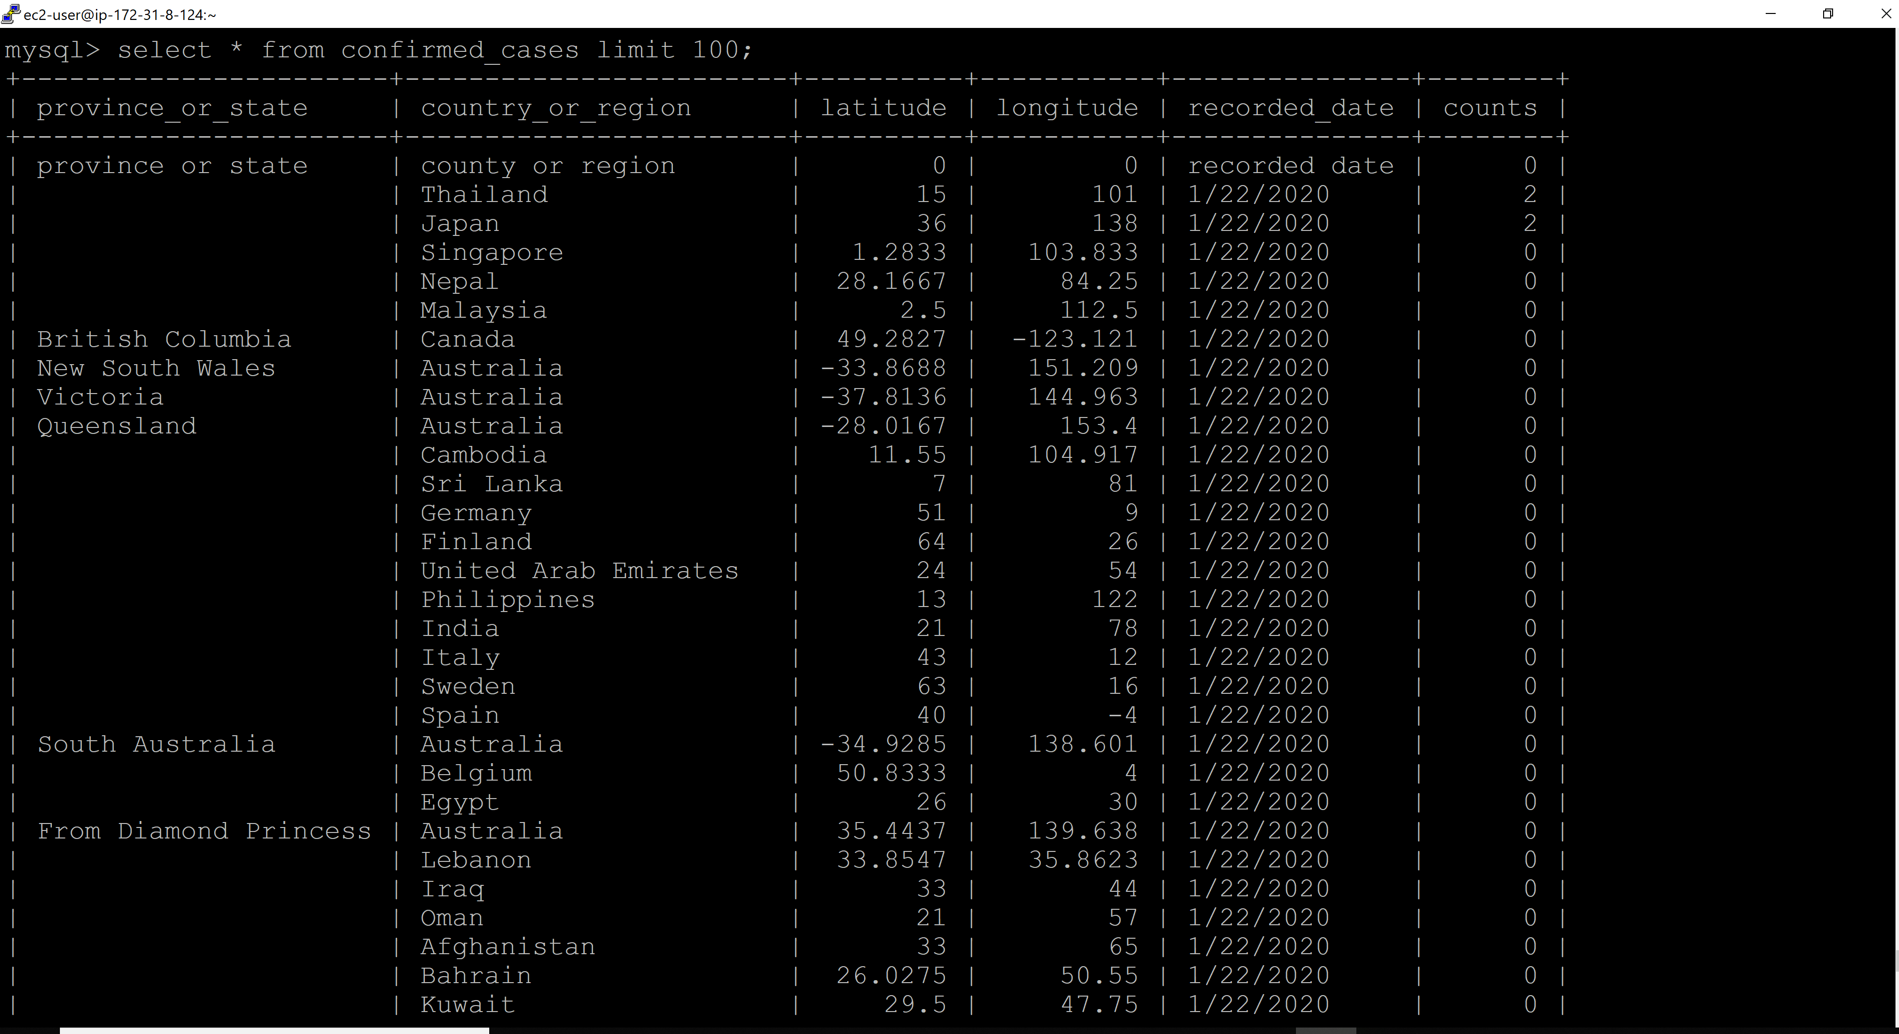

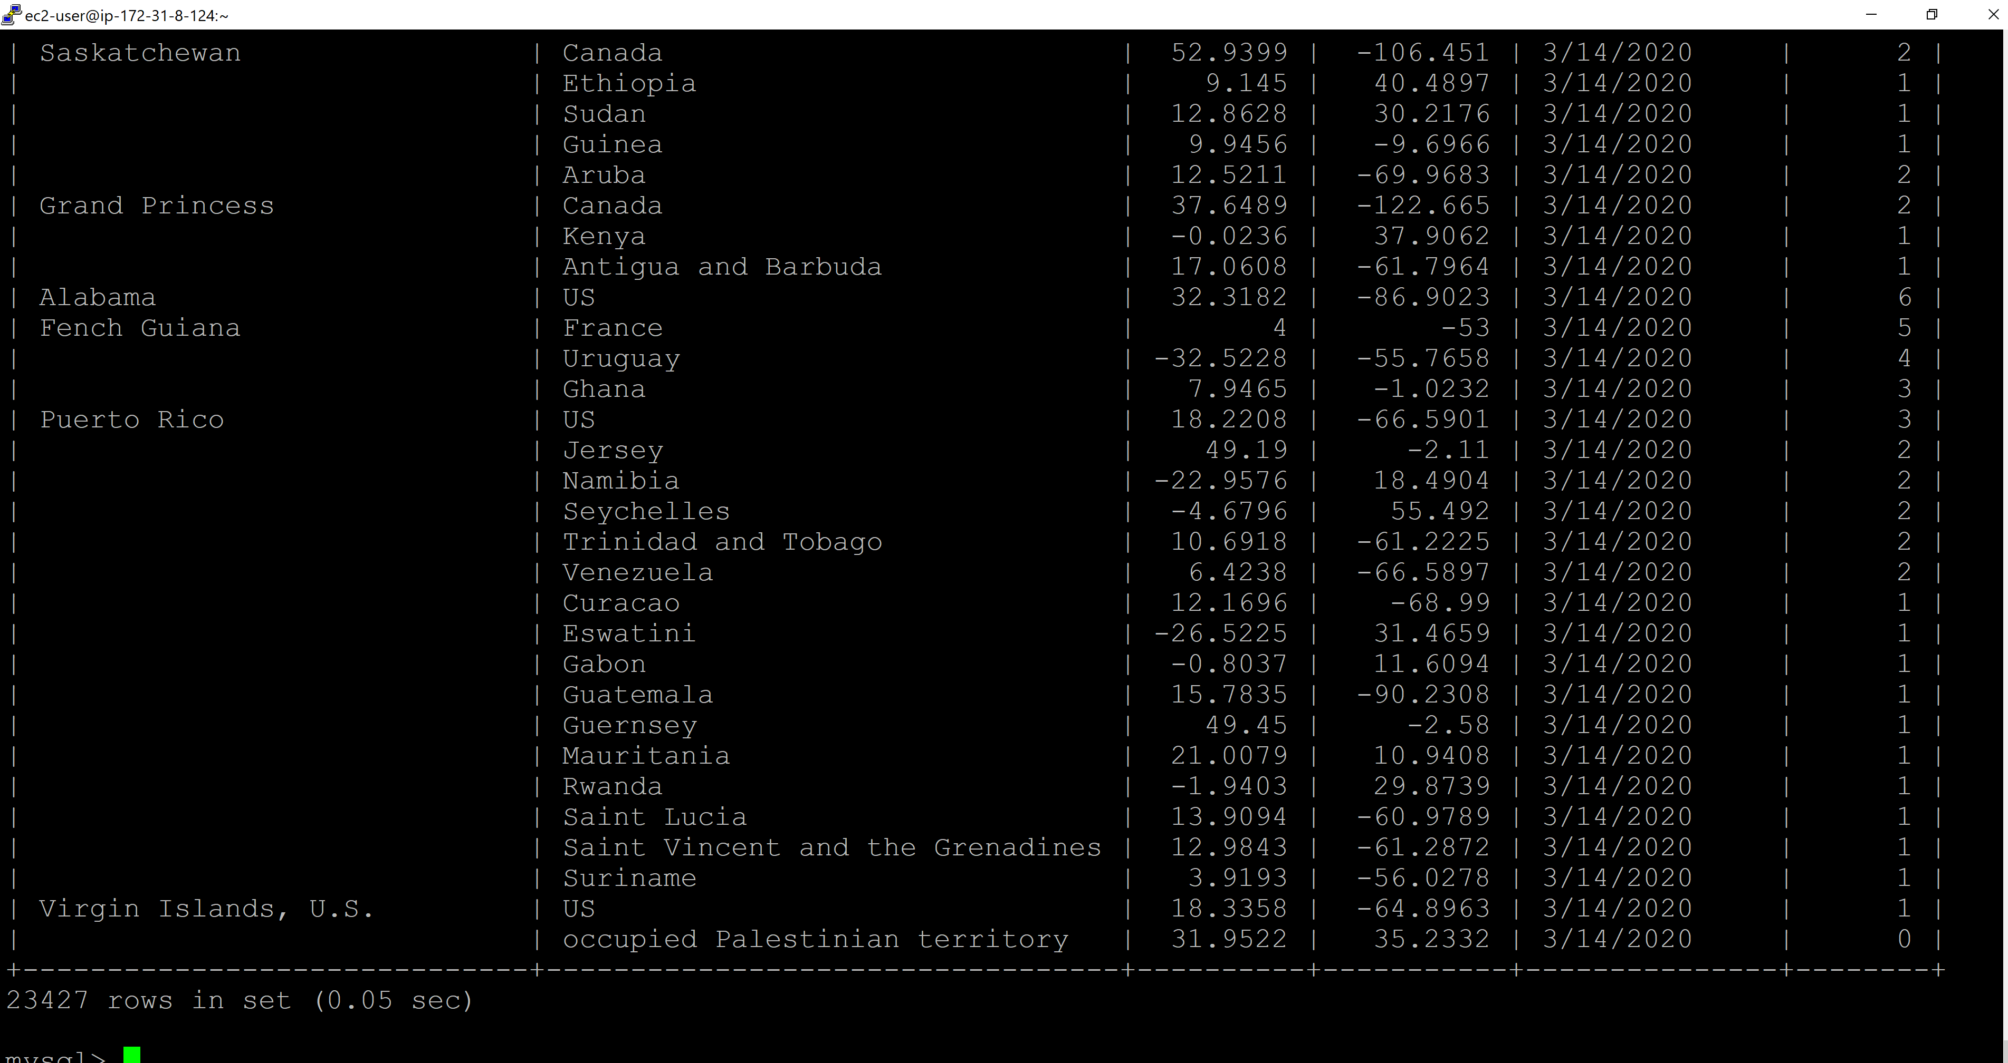

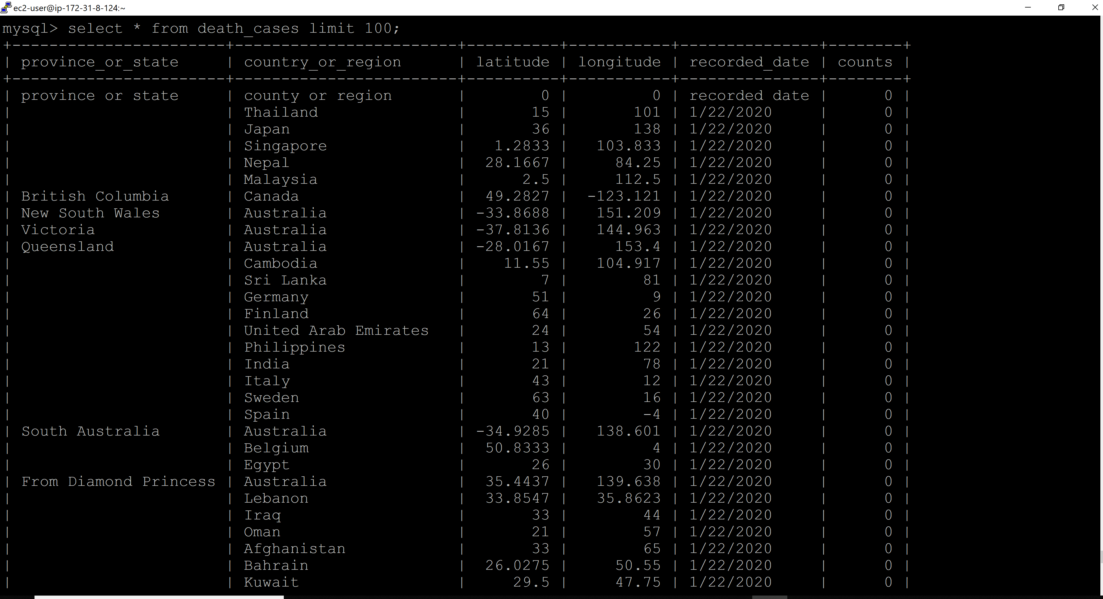

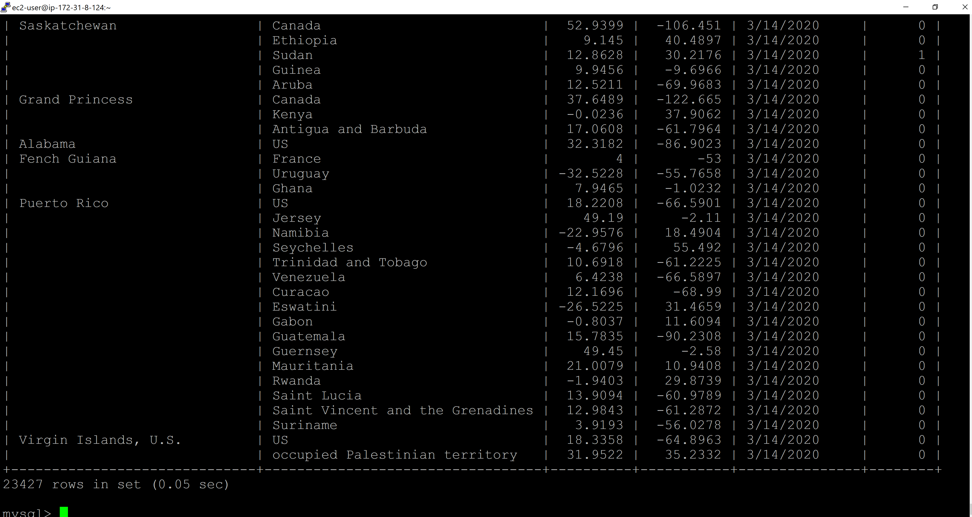

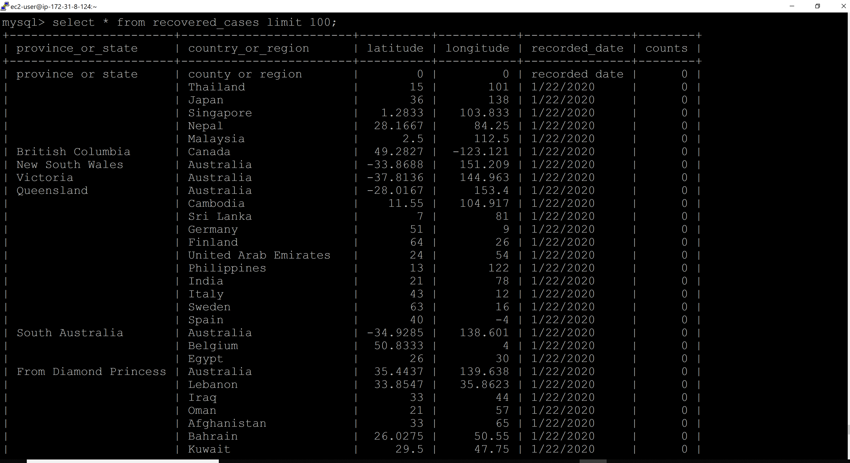

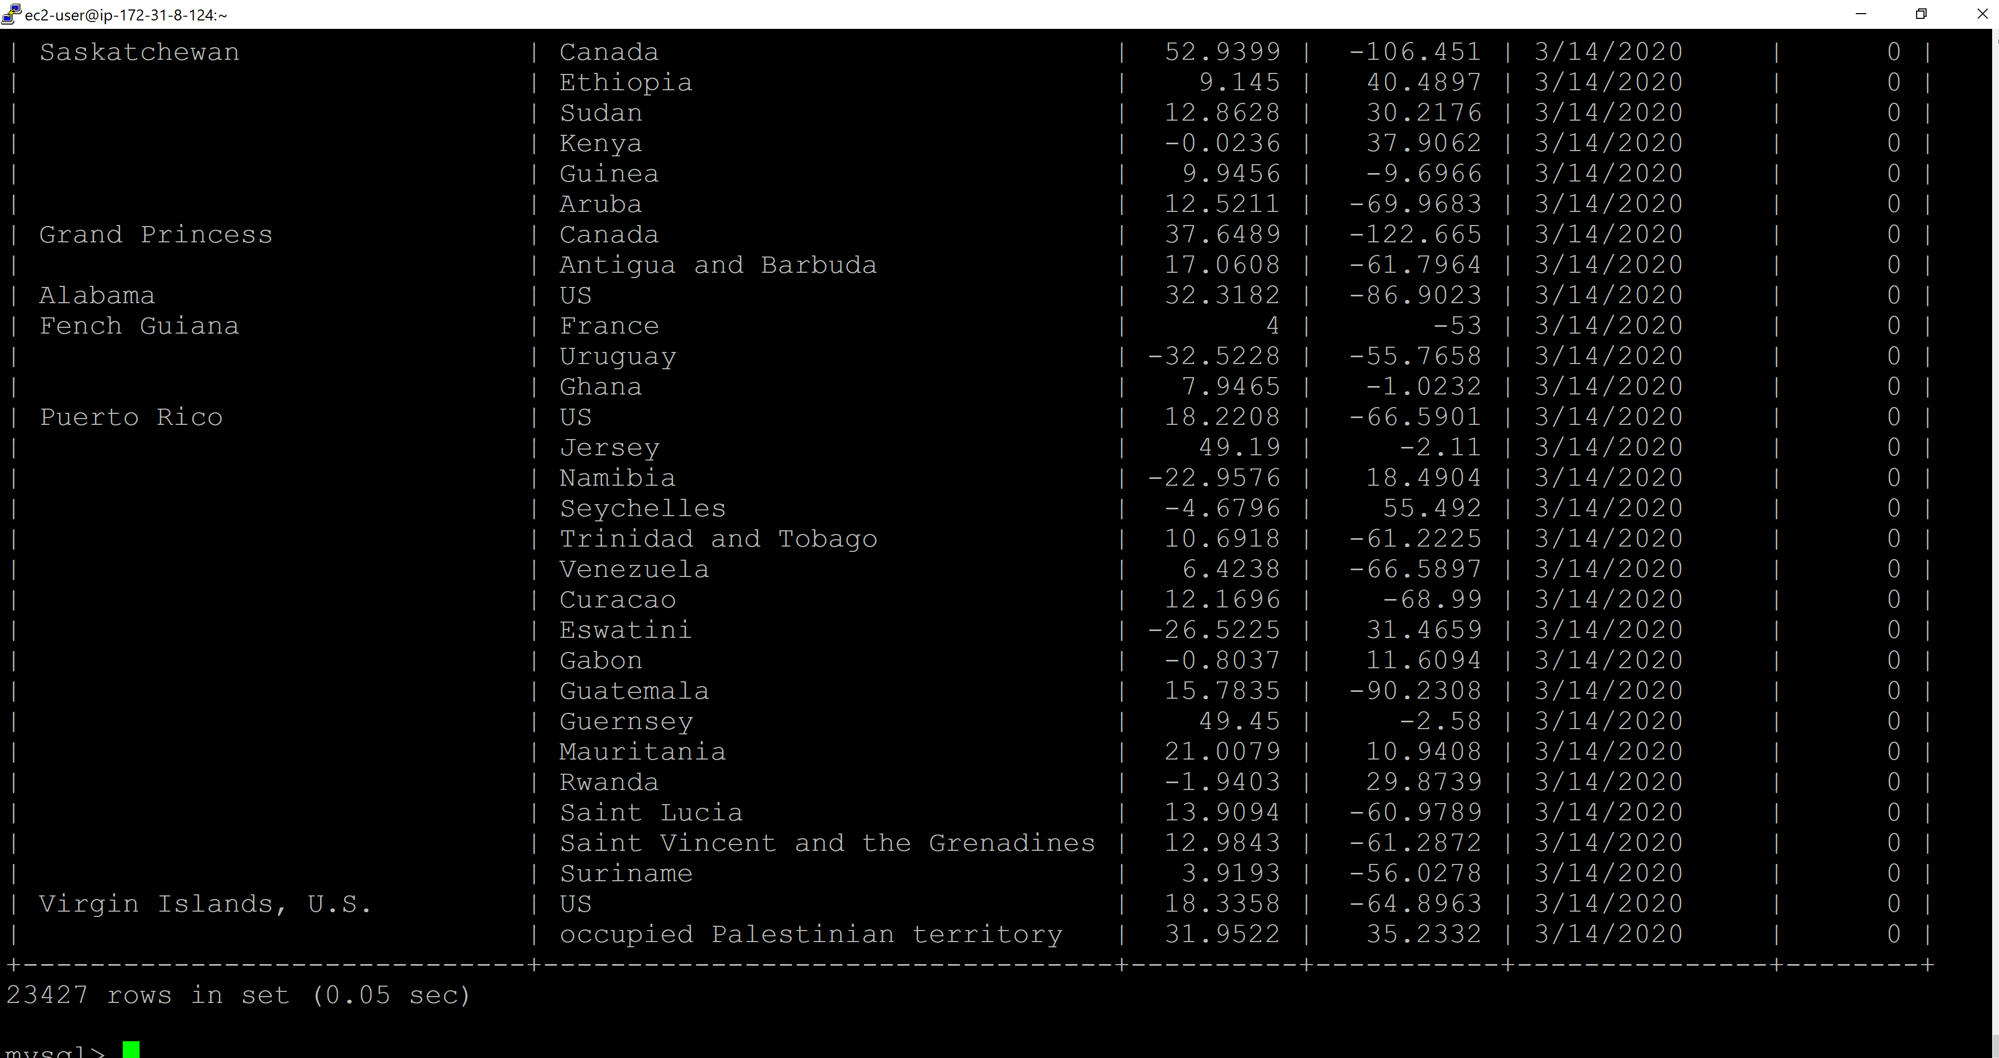

Python Script to load Firebase:

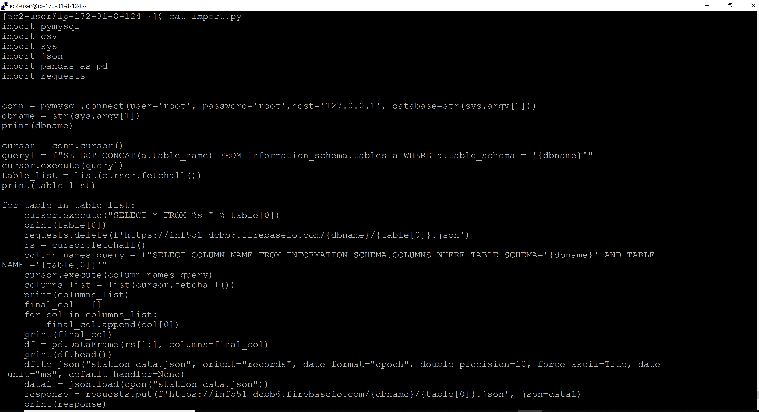

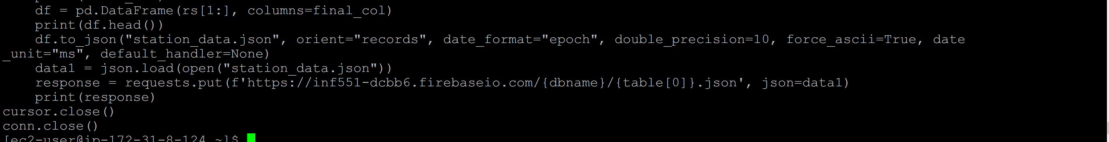

Data loaded in Firebase:

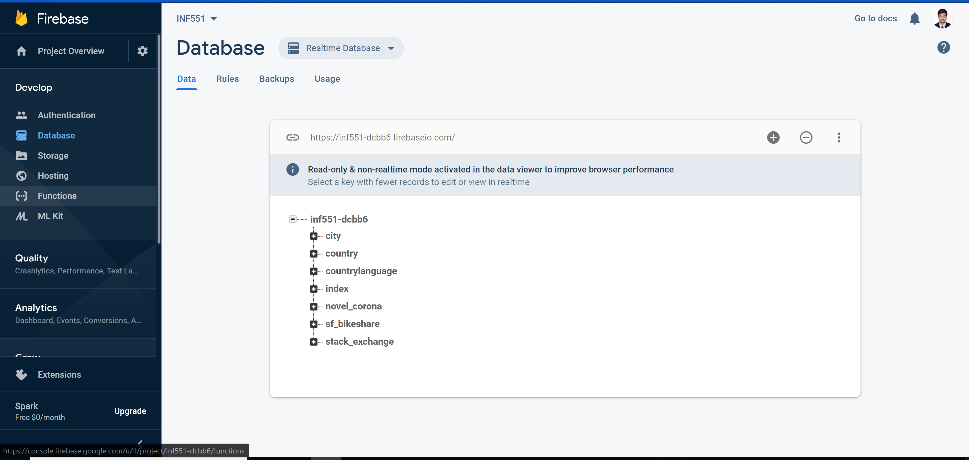

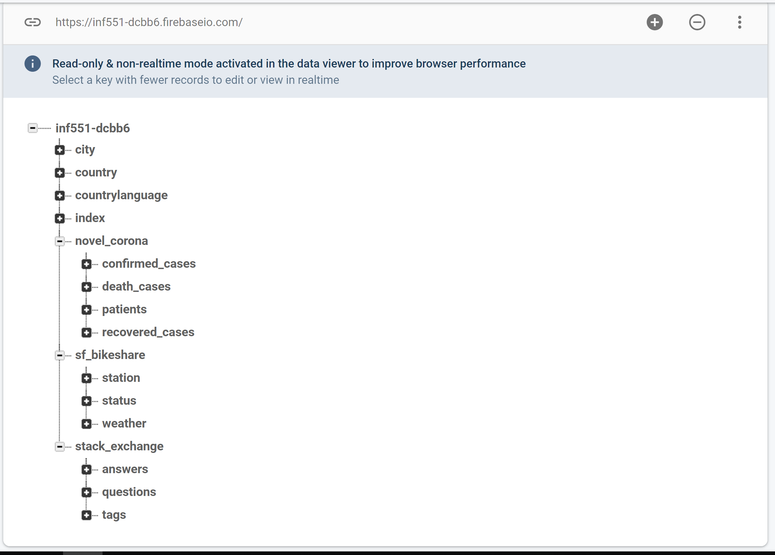

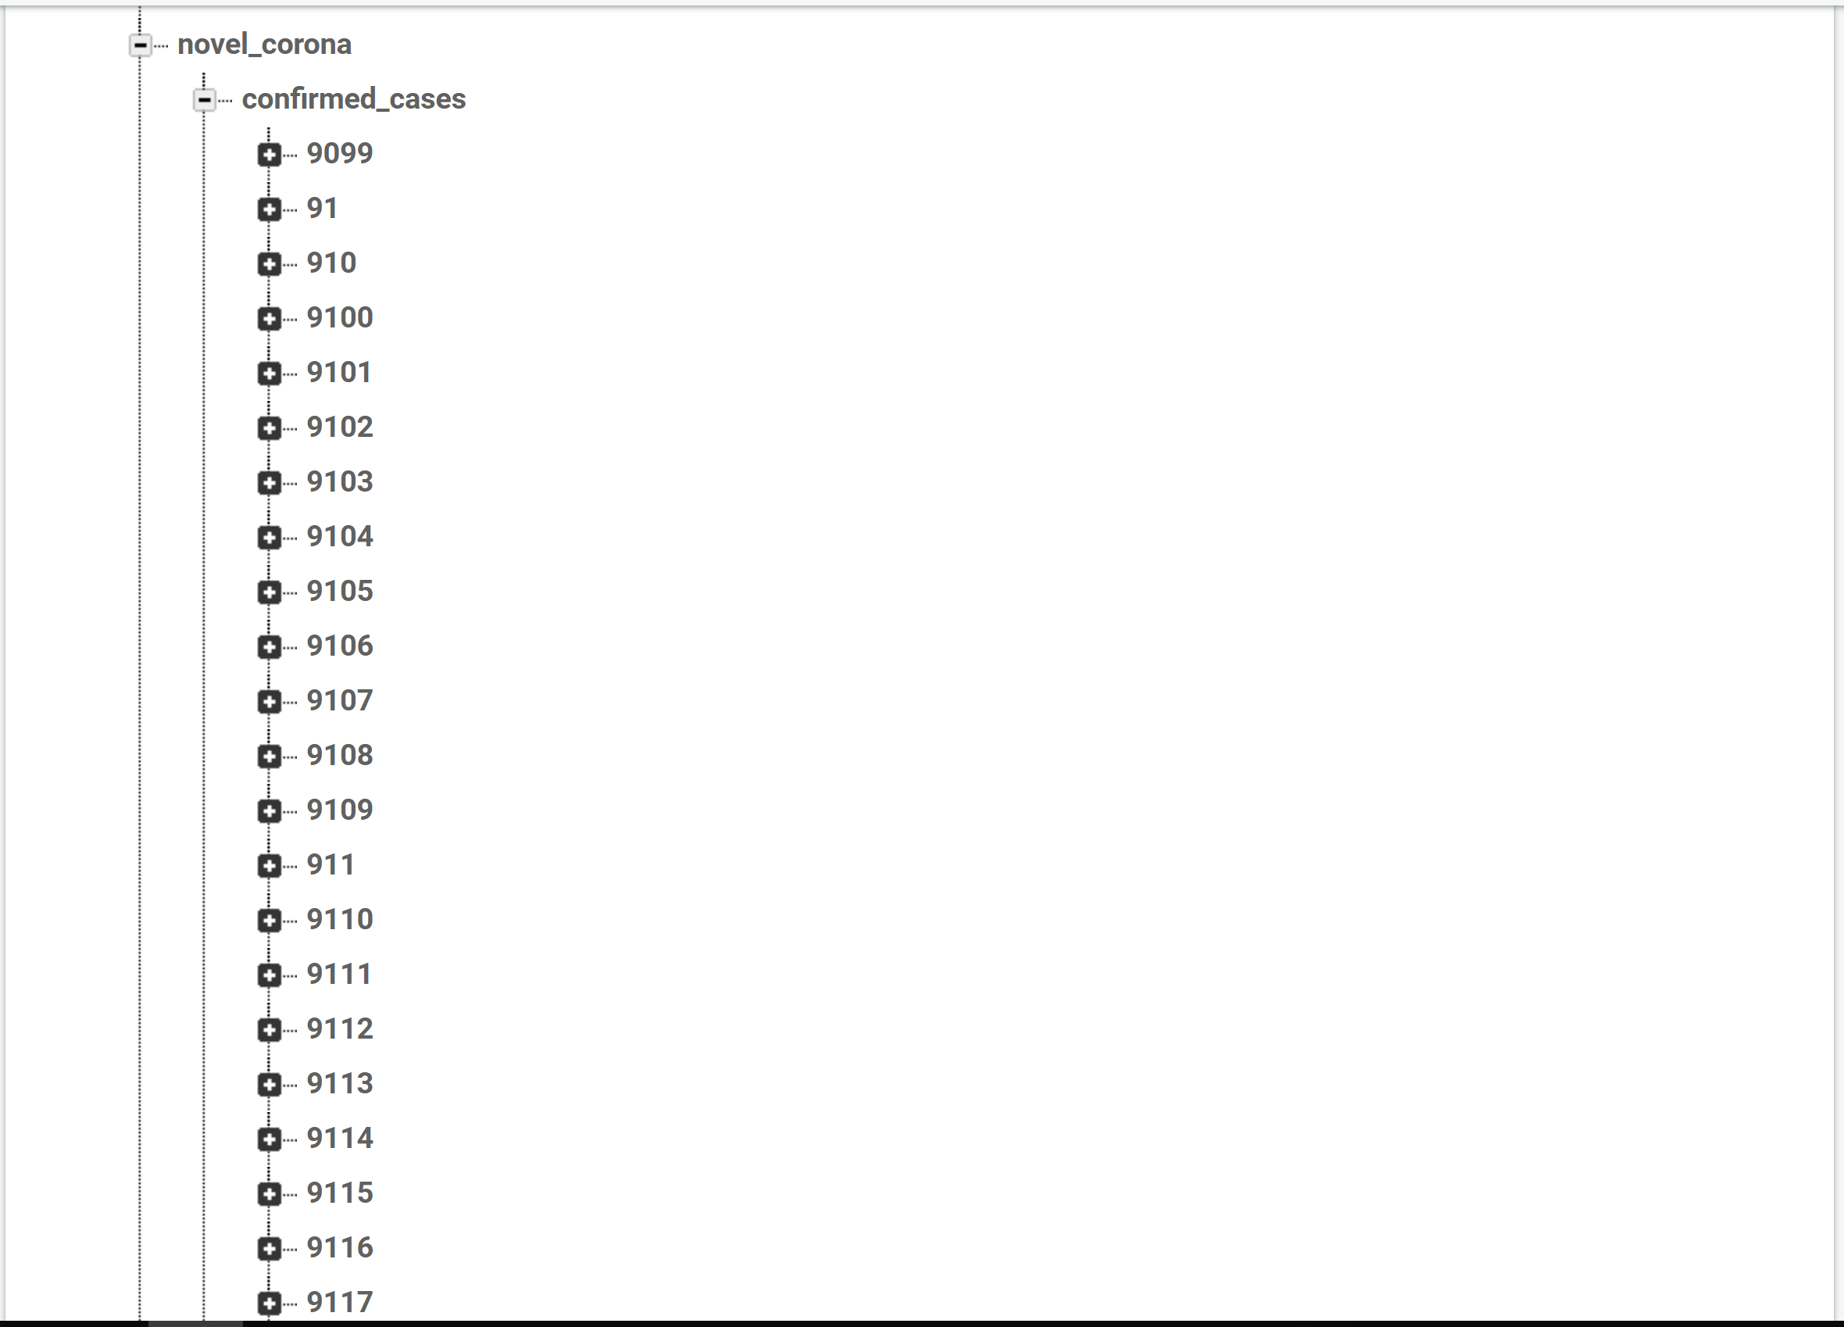

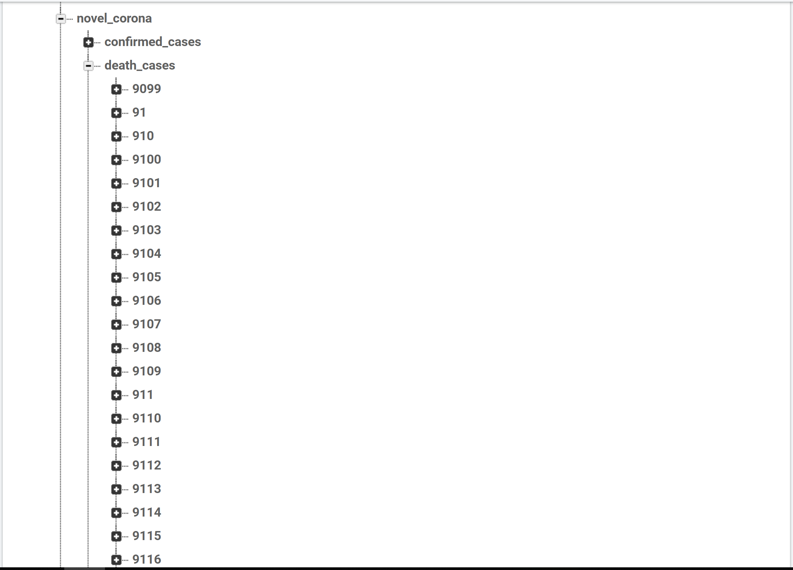

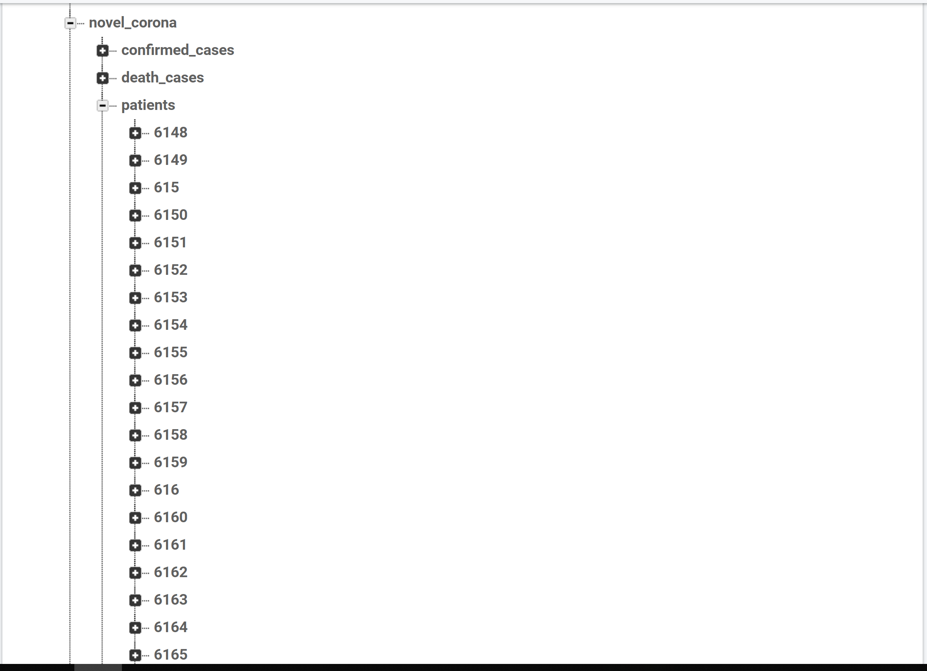

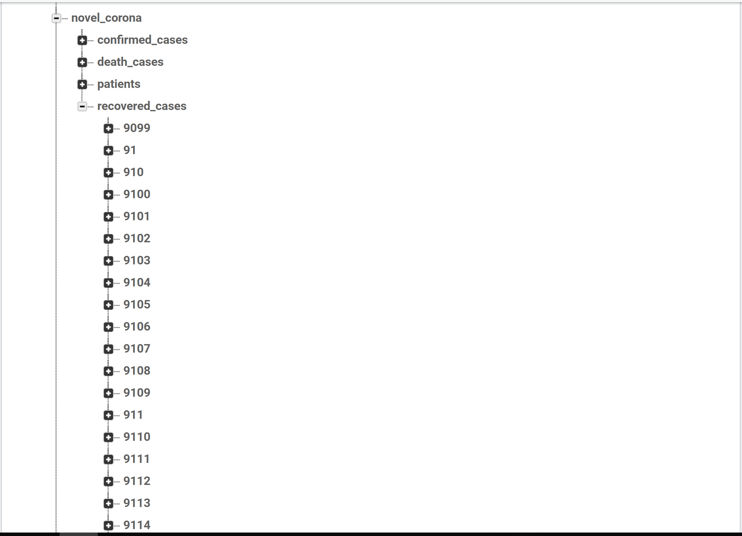

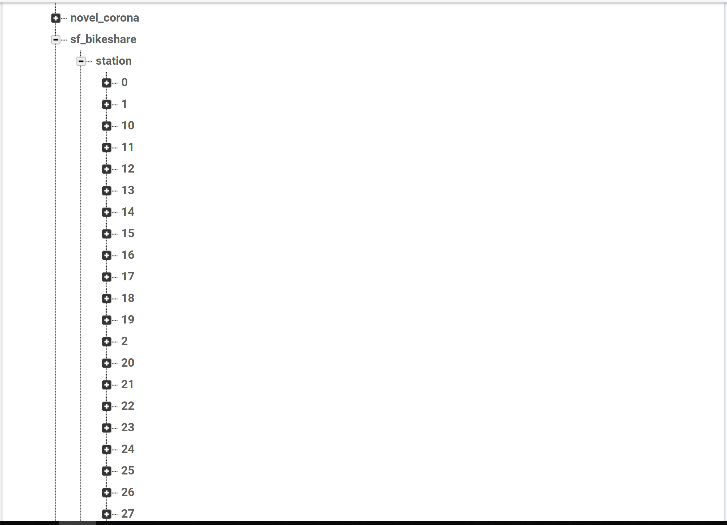

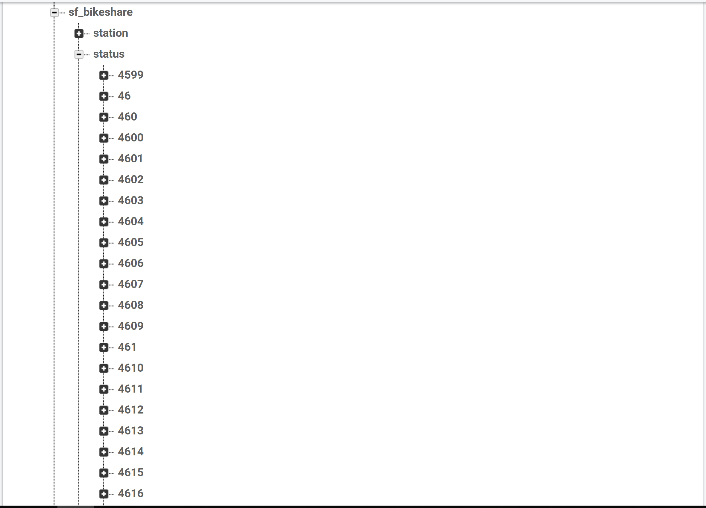

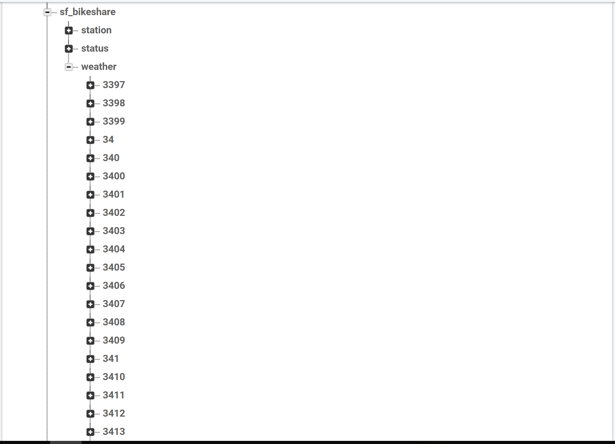

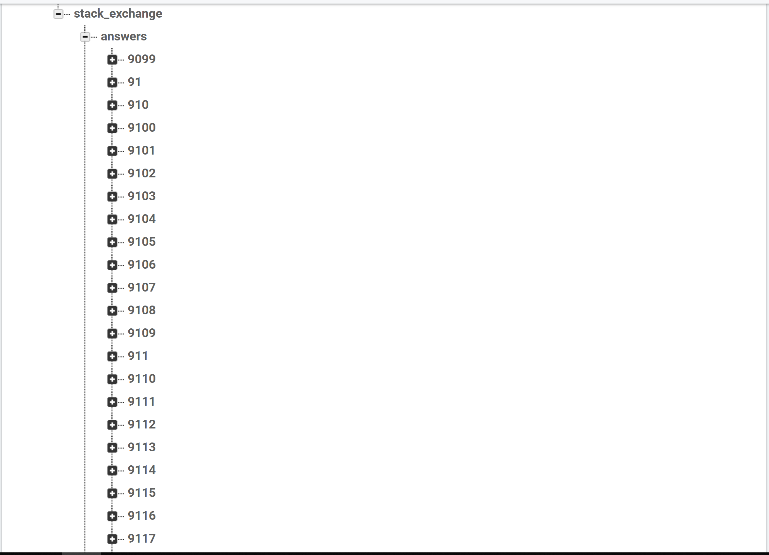

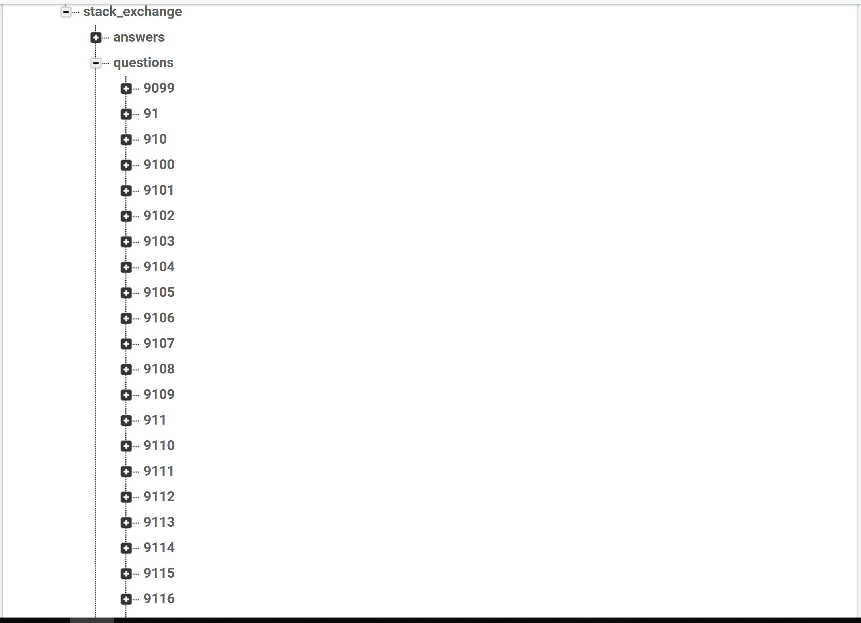

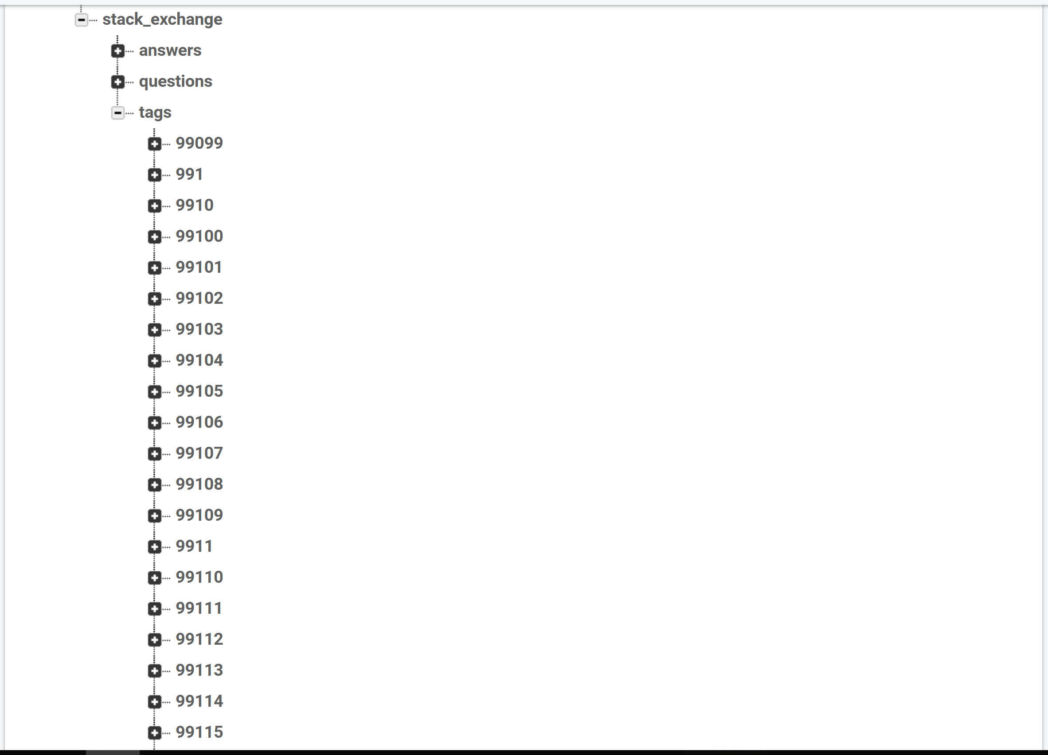

## Basic UI:

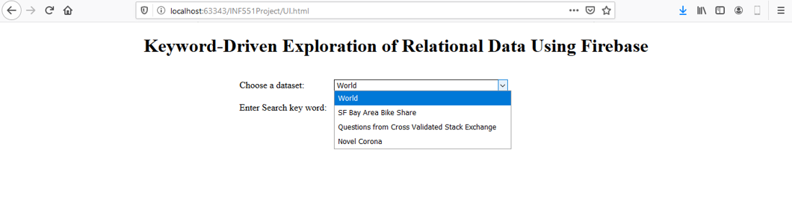

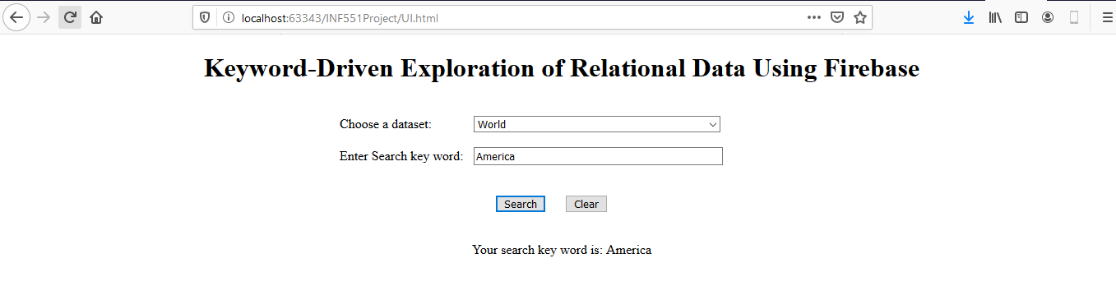

# Challenges encountered:

1. Handling large datasets was an issue due to file size being large to open on local file systems
2. Cleansing of large data sets was time consuming
3. Deciding on to a single format to store and access data
4. Generalizing the code to work on all datasets